Veer Narmad South Gujarat University,
Surat.

Department of Information and Communication Technology

B.Sc.(Information Technology)
6thSemester
PROJECT REPORT

M.Sc.(Information Technology)
5 Year Integrated Course
Year 2024-2025

Roro Ferry Services

Guided By:
Mr. Smit Mayurhai Chakrani
SPID: 2022026134

Mr. Nenish Jitendrabhai Jajadiya
SPID: 2022026176
Mr. Krunal Jiteshbhai Kaklotar
SPID: 2022026189

Dr. Veena Jokhakar
Submitted By:

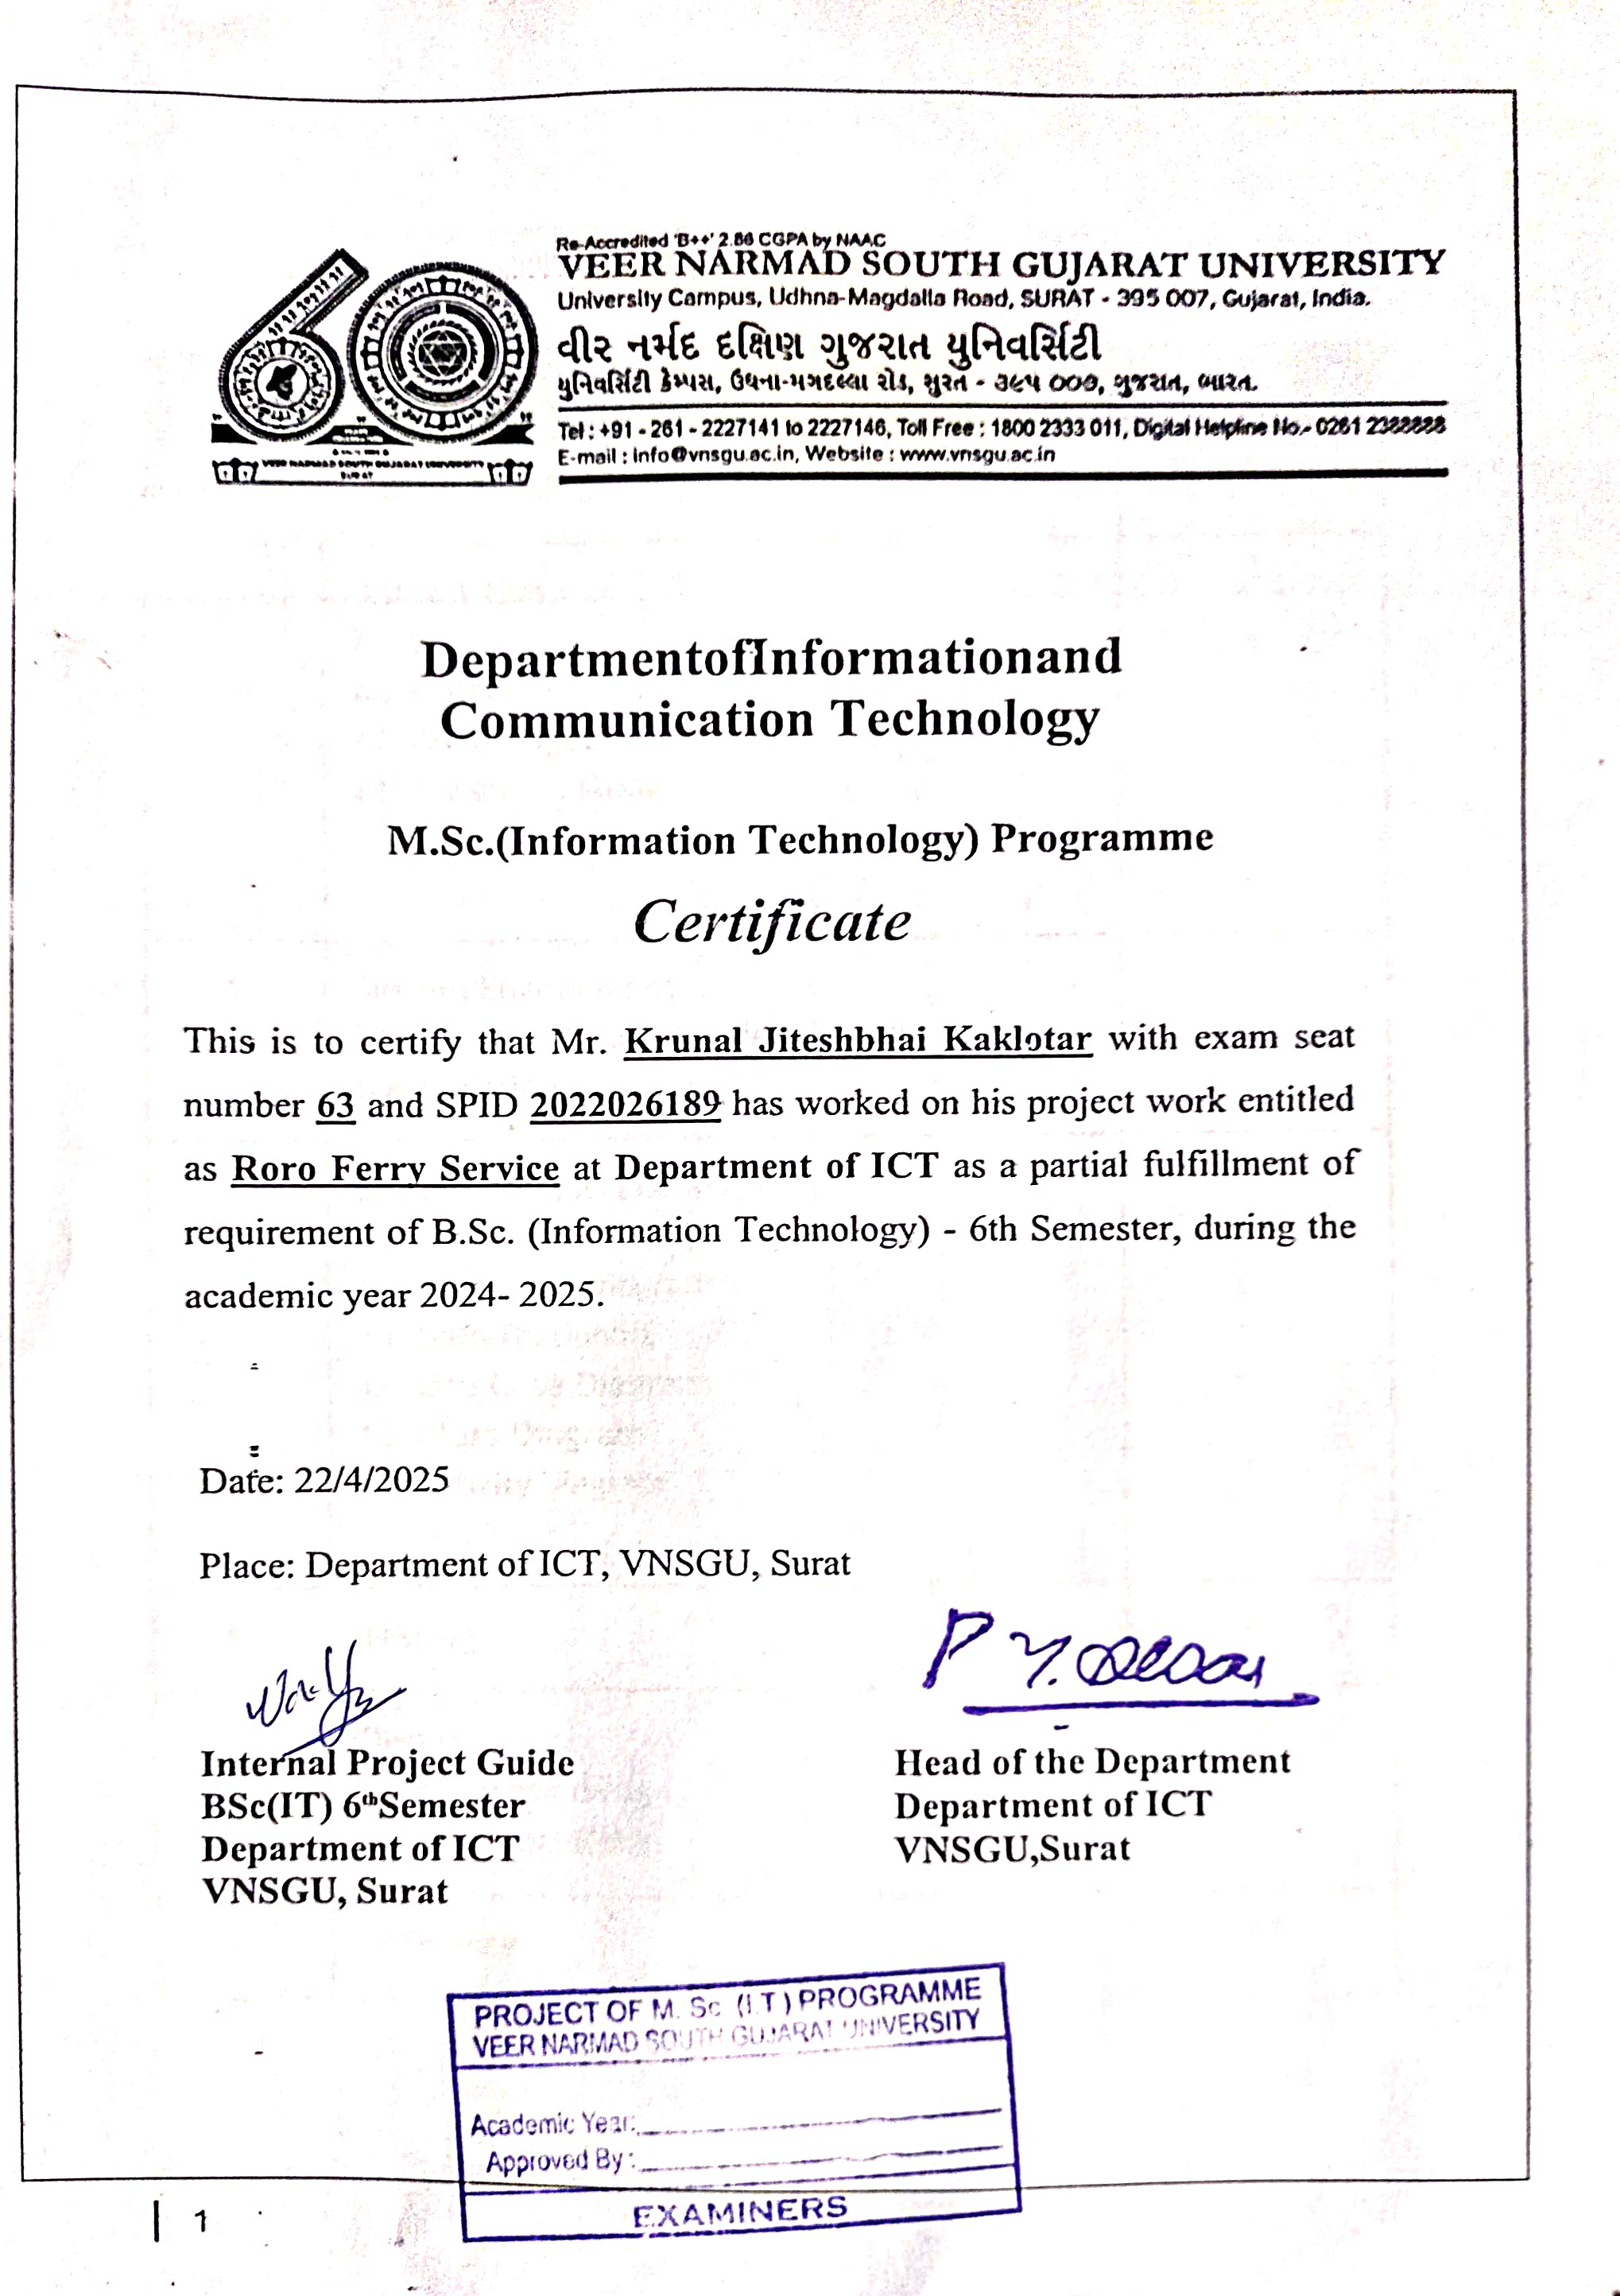

INDEX

No. | Particulars | Page
1. | Project Proﬁle | 1
2. | Introduction  - Scope  - Objective  - Advantages  - Feasibility Study | 3
3. | System Environment  - Hardware & Software Requirement Speciﬁcation | 7
4. | System Analysis and Modeling  - Entity Relationship Diagram  - Data Flow Diagram  - Data Dictionary  - Use Case Diagram  - Class Diagram  - Activity Diagram | 8
5. | Testing | 23
6. | Design  - Database design  - Interface design | 34
7. | Reference | 74

1.PROJECT PROFILE

ProjectTitle | Roro Ferry Services
ProjectDefinition | The Roro Ferry Service System is a PHP web app that makes ferry booking and management easy for passengers and admin.
Frontend | HTML, CSS, Java Script, Ajax, SwiperJs, Bootstarp
Backend | PHP
Database | MySQL
ProjectCategory | WebApplication
DocumentationTool | Ms-Office
Editor | VisualStudio
Duration | 3Months
GuidedBy | Dr.Veena Jokhakar
DevelopedBy | Mr. Smit Chakrani  Mr. Nenish Jajadiya  Mr. Krunal Kaklotar

2. INTRODUCTION

- RoroFerry gives safe and easy travel – You can travel with us by sea and we make your trip smooth and safe.

- Many routes and times help you travel when you want – We have different places you can go and different times to travel. You can choose what is best for you.

- New and clean ships make your trip nice and comfy – Our ferries are modern. They are clean and have good seats, clean bathrooms, and space for cars and trucks.

- We work hard to give good service and happy journeys – Our team is friendly. We try our best to help you have a good trip every time you travel with us.

2.1 SCOPE

Functional requirement of the project:

The purpose of this section is to cover each and every module of the web app project. Please review this section carefully and let us know your feedback if you would like to make any changes.

User Types
(Key Stack-holders) : The web app will have the following types of users

UserRole | Description | Platform
Admin | The admin can manage ferry trip packages, facilities, and user bookings. They can also handle user queries and update site settings for smooth operations. | Web Based Panel  (Admin Dashboard)
User | Users can easily book and cancel tickets for their ferry trips. They can also leave reviews for their travel experience and make payments for their bookings directly through the platform. | Web Based Panel  (Roro Ferry Site)

Admin Key Features:

- Manage Trip Packages – Admin can add, edit, or delete ferry routes and trip packages.

- Update Facilities & Features – Admin can update available services and features on ferries.

- Manage User Bookings – Admin can view, approve, or cancel user bookings.

- Handle User Queries – Admin can check and respond to user inquiries.

- Update Site Settings – Admin can edit homepage content, contact info, and other website details.

User Key Features:

- Book Tickets – Users can book ferry tickets easily through the platform.

- Cancel Tickets – Users can cancel their ferry tickets if needed.

- Leave Reviews – Users can leave feedback and reviews on their travel experience.

- Make Payments – Users can securely make payments for their bookings directly through the platform.

2.2 OBJECTIVE

- To design and implement a web-based RORO Ferry Management System with separate interfaces for both users and administrators.

- To allow users to register, log in, and manage their profiles while booking ferry packages based on their preferences (Local, Silver, Gold, Diamond).

- To enable users to view ferry schedules and book tickets for any of the available packages, with the same booking process for all package types.

- To develop an admin panel for managing ferry schedules, routes, pricing, user data, and customer reviews effectively.

- To ensure a smooth and responsive user experience with dynamic content loading.

- To securely manage booking records, payment transactions, seat availability, and customer feedback using a robust database system.

2.3 Advantage

The RORO Ferry Management System provides users with the ability to book ferry tickets online from anywhere at any time.
It eliminates the need to visit physical booking counters, making the process faster and more convenient.
The system displays real-time seat availability for Packages, helping users make informed booking decisions.
Secure online payment integration ensures safe and quick transactions, with proper record-keeping.
Users can choose from multiple packages like Local, Gold, Diamond, and Platinum based on their travel preferences.
Admin can manage ferry schedules, package details, and user information from a centralized dashboard.
Booking history and payment records are maintained in the system for both users view when needed.

2.4 Facibility Study

- Feasibility study is an assessment of the practicality of a proposed project or System.

- Feasibility study is conducted once the problem is clearly understood.

- The system has been tested for feasibility in the following points.
1. Technical Feasibility
2. Economical Feasibility
3. Operational Feasibility

1. Technical Feasibility
- Our project is technically feasible because of the below mentioned feature.

- We have completed admin module and for feasibility study, we studied complete functionality of the admin module as described in the Software Requirement Specification(SRS).

- Admin can successfully login to the system and perform tasks assigned to the admin.

2.Economical Feasibility
- This is very important aspect to be considered while developing a project .

- We decided the technology based on the minimum possible cost factor.

3.Operational Feasibility
- The proposed system is fully GUI based and it is very user friendly.
3. System Environment

3.1 Hardware & Software Requirement Speciﬁcation

SOFTWARE REQUIREMENT

HEADING | DISCRIPTION
Operating System | Windows, IOS, Linux
PHP | Version 7 or above
Xampp | Version 3.3.0
MySQL | Version 5.2.1
Web Browser | Microsoft Edge, Google Chrome, Safari, Firefox
Server | Localhost

HARDWARE REQUIREMENT

HEADING | DISCRIPTION
Hard Disk | 256 GB
Monitor | 15’’ LED
Input Devices | Keyboard , Mouse
Ram | 4 GB
Microprocessor | i3 5th Gen
Internet Connection | 512 kbps
4. System Analysis and Modeling

4.1 Er Diagram

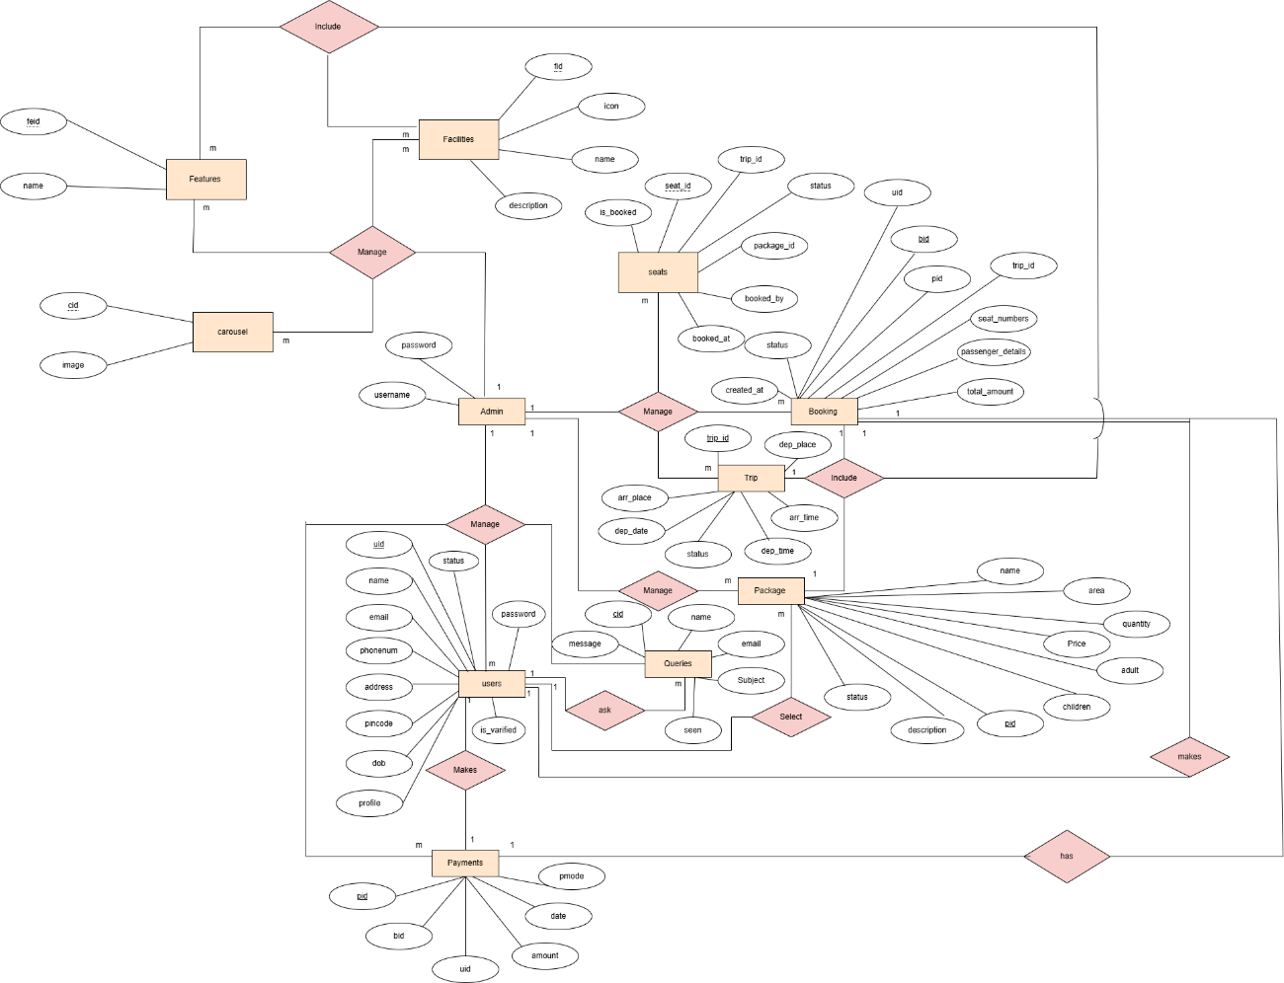

4.2 Data Flow Diagram(DFD)

4.2.1 Level 0 DFD (Context Level)

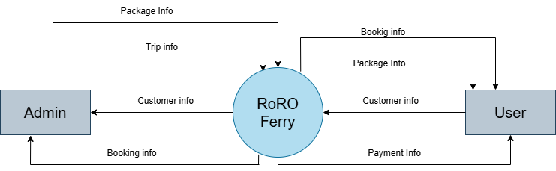

4.2.2 Level 1 DFD

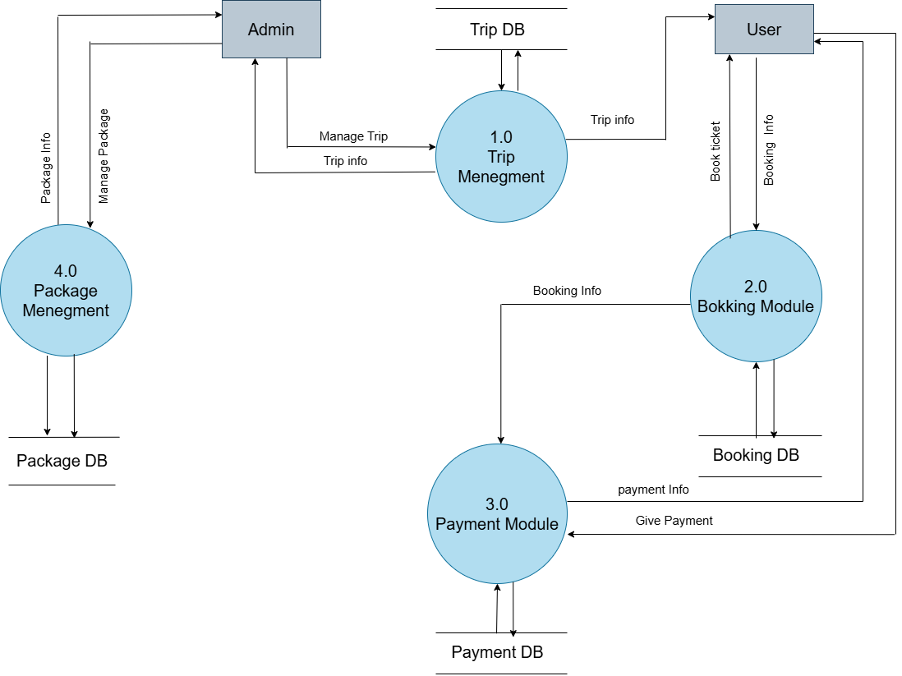

4.2.2 Level 2 DFD

- Trip Management

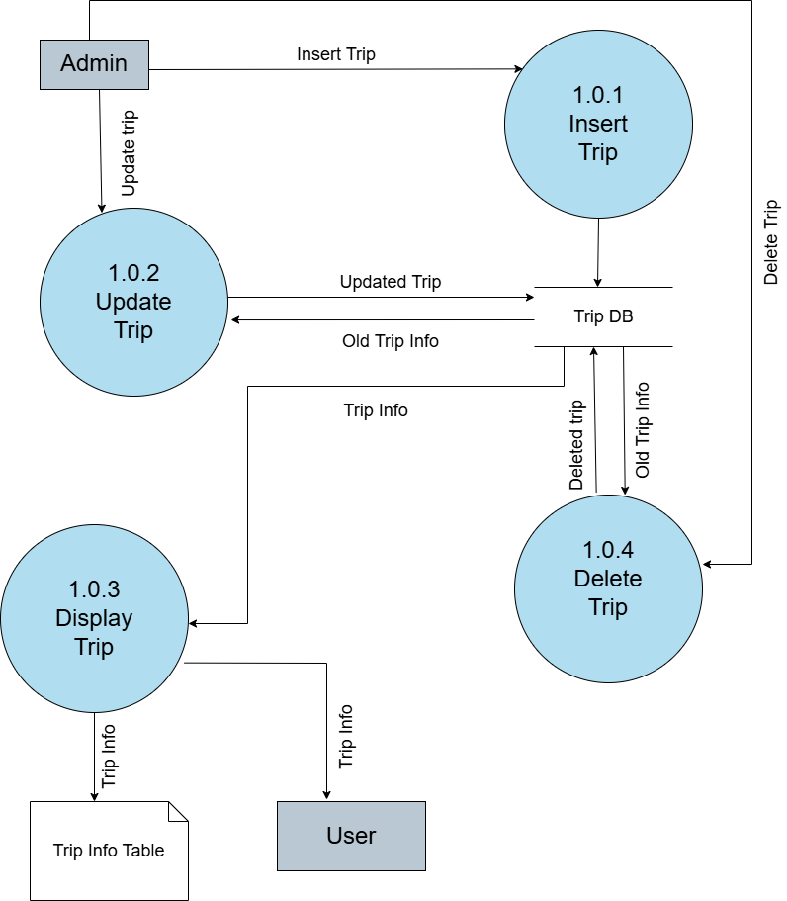

- Package management

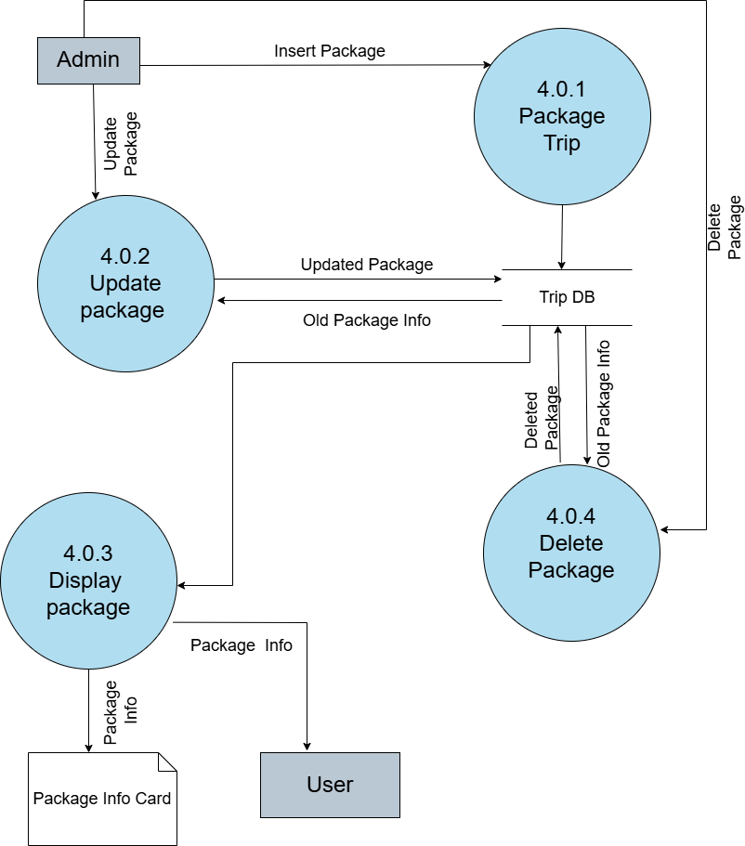

- Booking management

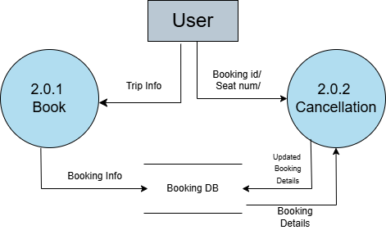

- Payment management

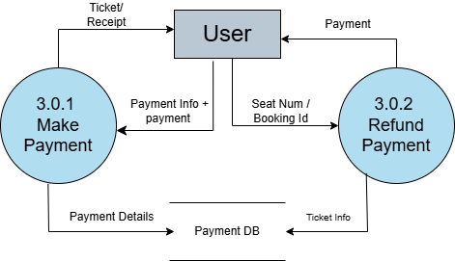

4.3 Data Dictionary

Name | Admin
Alias | -
Where & How Use | Backend/admin login and access control
Description | username, password
Format | Alphanumeric

Name | Users
Alias | -
Where & How Use | User registration, login, and profile management
Description | id, name , emai, address, phonenum, pincode, dob, profile, password, is_verified, token, token_expire, status, created_at, reset_token, token_expiry
Format | Alphanumeric / Varchar / DateTime

Name | Booking
Alias | -
Where & How Use | For user trip booking and transaction details
Description | bid, uid, pid, trip_id, seat_numbers, passenger_details, total_amount, created_at, status
Format | pdf

Name | Package
Alias | -
Where & How Use | Display available packages on website
Description | pid, name, area, price, quantity,adult, children, description, status, removed
Format | Alphanumeric / Integer

Name | Trip
Alias | -
Where & How Use | Used to list trips and their details
Description | trip_id, trip_day, dep_place, arr_place, dep_date, dep_time, arr_time, status
Format | Alphanumeric / Date

Name | Seats
Alias | -
Where & How Use | Manages seat availability and allocation
Description | seat_id, trip_id, package_id, seat_number, status, is_booked, booked_by, booked_at
Format | Numeric / Boolean

Name | Queries
Alias | -
Where & How Use | Contact form submissions and user queries
Description | id, name, email, subject, message, seen
Format | Alphanumeric / Varchar / DateTime

Name | Facilities
Alias | -
Where & How Use | Lists general facilities offered in packages or trips
Description | fid, icon, name, description
Format | Alphanumeric / Boolean

Name | Features
Alias | -
Where & How Use | Highlights key features of the website/packages
Description | feid, name
Format | Alphanumeric / Boolean

4.4 Use case Diagram

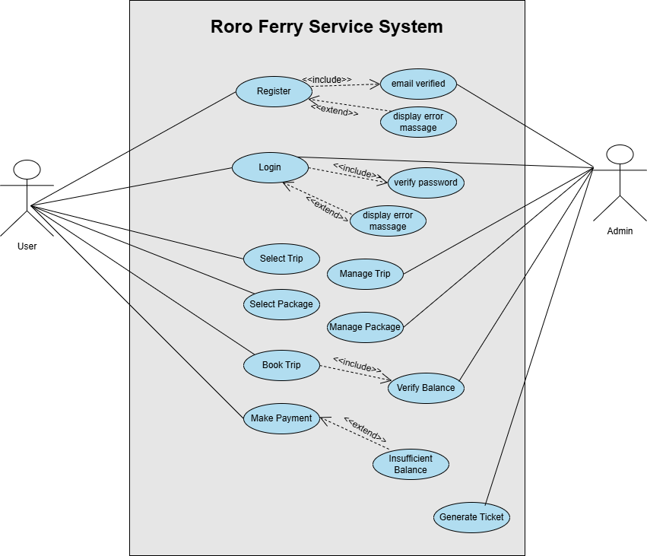

4.5 Class Diagram

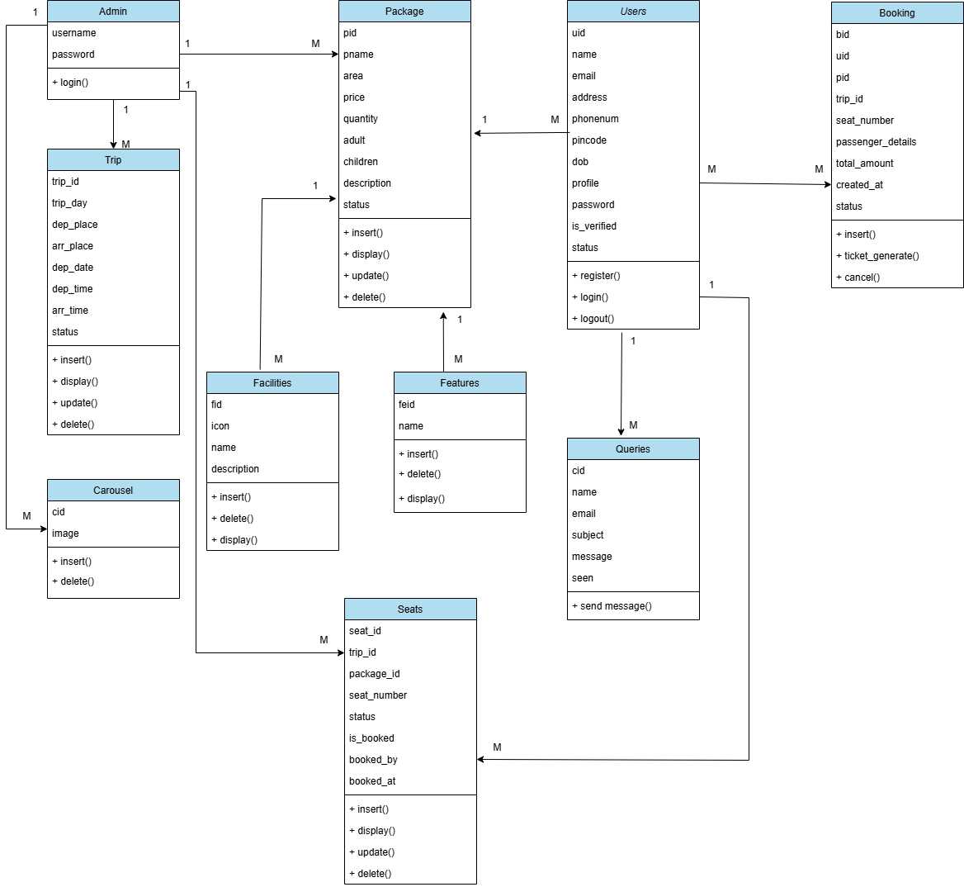

4.6 Activity Diagram

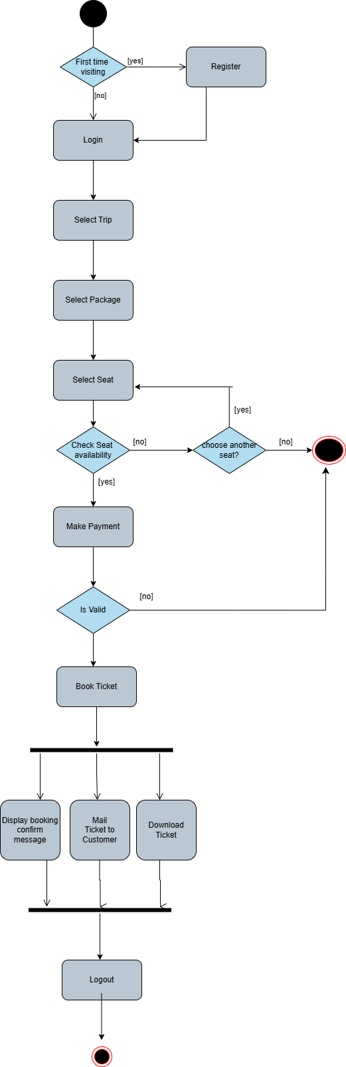

5. Testing

5.1 Unit Testing

- Test Case for User Login:

Test field | Test Data | Executed result | Test result
Email | Null | Invalid | Please fill out this field
 | Krunal.gmail.com | Invalid | Please include @ in email id
Password | Null | Invalid | Please fill out this field.
 | krunal | Invalid | Incorrect password
Role | Null | Invalid | Please fill out this field
 | Admin | User Login | Invalid credentials or not verified

- Test Case for User Registration

Test field | Test Data | Executed result | Test result
Name | Null | Invalid | Please fill out this field
 | 123 | Invalid | Enter a valid name(2-50 letters).
Email | Null | Invalid | Please fill out this field.
 | krunal | Invalid | Enter a valid email address.
Phone number | Null | Invalid | Please fill out this field
 | Abc & less than 10 digit | Invalid | Phone number should be 10 digits.
picture | Null | valid | -
Address | Null | Invalid | Address cannot be empty.
Pincode | 39500 | invalid | Enter a valid 6-digit pincode.
Date of Birth | Null | Invalid | Please fill out this field
Password | Krunal | Invalid | Must be 8+ chars with letter, number & special char.
Confirm Password | Null | invalid | Passwords do not match.

- Test Case for package add/edit
Test field | Test Data | Executed result | Test result
Name | Null | Invalid | Please fill out this field.
Aria | Null | Invalid | Please fill out this field.
Price | Null | Invalid | Please fill out this field.
Quantity | Null | Invalid | Please fill out this field.
Adult | Null | Invalid | Please fill out this field.
Children | Null | Invalid | Please fill out this field.
Facilities | Null | Invalid | Please fill out this field.
Features | Null | Invalid | Please fill out this field.
Description | Null | Invalid | Please fill out this field.

- Test Case for feature

Test field | Test Data | Executed result | Test result
Name | Null | Invalid | Please fill out this field.

- Test Case for facilities

Test field | Test Data | Executed result | Test result
Name | Null | Invalid | Please fill out this field.
Icon | Null | Invalid | Please fill out this field.
Description | Null | Invalid | Please fill out this field.

Test Case for schedule
Test field | Test Data | Executed result | Test result
Day | Null | Invalid | Please fill out this field.
Departure Date | Null | Invalid | Please fill out this field.
Departure Time | Null | Invalid | Please fill out this field.
Arrival Time | Null | Invalid | Please fill out this field.

- Test Case for contact us

Test field | Test Data | Executed result | Test result
Address | Null | Invalid | Please fill out this field.
Social Links | Null | Invalid | Please fill out this field.
Google map | Null | Invalid | Please fill out this field.
Phone Number | Null | Invalid | Please fill out this field.
Email | Null | Invalid | Please fill out this field.
Iframe src | Null | Invalid | Please fill out this field.

- Test Case for carousel

Test field | Test Data | Executed result | Test result
Image | Null | Invalid | Please fill out this field.

- Test Case for feature

Test field | Test Data | Executed result | Test result
Name | Null | Invalid | Please fill out this field.

- Test Case for facilities

Test field | Test Data | Executed result | Test result
Name | Null | Invalid | Please fill out this field.
Icon | Null | Invalid | Please fill out this field.
Description | Null | Invalid | Please fill out this field.

- Test Case for schedule
Test field | Test Data | Executed result | Test result
Day | Null | Invalid | Please fill out this field.
Departure Date | Null | Invalid | Please fill out this field.
Departure Time | Null | Invalid | Please fill out this field.
Arrival Time | Null | Invalid | Please fill out this field.

- Test Case for contact us

Test field | Test Data | Executed result | Test result
Address | Null | Invalid | Please fill out this field.
Social Links | Null | Invalid | Please fill out this field.
Google map | Null | Invalid | Please fill out this field.
Phone Number | Null | Invalid | Please fill out this field.
Email | Null | Invalid | Please fill out this field.
Iframe src | Null | Invalid | Please fill out this field.

5.2 Functional Testing

Functional testing is a quality assurance (QA) process and a type of black-box testing that bases its test cases on the specifications of the software component under test. Functions are tested by feeding them input and examining the output, and internal program structure is rarely considered (unlike white-box testing). Functional testing usually describes what the system does.

Since functional testing is a type of black-box testing, the software's functionality can be tested without knowing the internal workings of the software.

Functional testing does not imply that you are testing a function (method) of your module or class. Functional testing tests a slice of the functionality of the whole system.

1. User Account Creation & Verification

- Test Case 1.1: Verify user registration with valid data (name, email, password, etc.).
  - Expected: Account created successfully; verification email/SMS is sent.

- Test Case 1.2: Attempt registration with already registered email.
  - Expected: Error message shown.

- Test Case 1.3: Attempt to register without completing required fields.
  - Expected: Validation errors displayed.

2. Sign In / Sign Out & User Data Load

- Test Case 2.1: Sign in with valid credentials.
  - Expected: User is logged in and dashboard loads with user data.

- Test Case 2.2: Sign in with invalid credentials.
  - Expected: Error message is displayed.

- Test Case 2.3: Sign out after login.
  - Expected: Session ends and redirects to login page.

3. Change Password / Delete Account

- Test Case 4.1: Change password with correct old password.
  - Expected: Password updates successfully.

4. Transaction Records Admin Side (CRUD)

- Test Case 5.1: Create a transaction with all required fields.
  - Expected: Transaction is saved and shown in the list.

- Test Case 5.2: Edit a saved transaction.
  - Expected: Updated details are reflected correctly.

- Test Case 5.3: Delete a transaction and confirm.
  - Expected: Transaction is removed from the record list.

5. Export Transactions

- Test Case 6.1: Click export (PDF/Excel).
  - Expected: File downloads with proper transaction data.

6. Analysis (Filtering)

- Test Case 7.1: Apply filters by date, category
  - Expected: Only matching transactions are shown.

8. Home Dashboard Analysis

- Test Case 8.1: Load dashboard after login.
  - Expected: Analysis widgets and summary charts display latest data.

7. All Tools (Calculator, Budgeting, etc.)

- Test Case 10.1: Use calculator or tool feature.
  - Expected: Tool functions correctly with correct results.

8. Payment Gateway Integration

Test Case 1.1: Verify successful payment transaction

- Description: Ensure that a valid payment is processed successfully.
- Steps:
  - Select a payment method (e.g., credit card, digital wallet).
  - Enter payment details (valid card number, expiration, CVV, etc.).
  - Complete the payment.
- Expected Result: Payment is successful, and a confirmation message is displayed along with a transaction ID.

Test Case 1.2: Verify payment with insufficient funds

- Description: Ensure that payments are rejected when the user does not have enough funds.
- Steps:
  - Select a payment method.
  - Enter payment details with an invalid or insufficient balance.
  - Attempt to complete the payment.
- Expected Result: Payment fails with an error message indicating insufficient funds.

Test Case 1.3: Verify payment with expired credit card

- Description: Ensure the payment fails if the card has expired.
- Steps:
  - Select a payment method.
  - Enter payment details with an expired card.
  - Attempt to complete the payment.
- Expected Result: Payment fails with an error message indicating the card has expired.

Test Case 1.4: Verify successful payment using a promo code

- Description: Test applying a valid promo code to the payment process.
- Steps:
  - Select a payment method.
  - Apply a valid promo code (if any).
  - Complete the payment.
- Expected Result: Promo code is applied successfully, and the correct discount is reflected in the final payment amount.

Test Case 1.5: Verify failed payment due to incorrect payment details
- Description: Ensure that the payment fails when the user enters incorrect payment details.
- Steps:
  - Select a payment method.
  - Enter incorrect payment details (e.g., wrong card number).
  - Attempt to complete the payment.
- Expected Result: Payment fails, and an error message appears, indicating incorrect payment details.

5.3 Environment Testing

A testing environment is a software and hardware configuration that allows testing teams to run test cases. In other words, it enables test execution with properly configured hardware, software, and network.

The test bed or test environment is set up according to the requirements of the Application Under Test. On rare occasions, a test bed may be a mix of the test environment and the test data with which it interacts.

Software testing success is ensured by setting up the correct test environment. Any errors in this procedure may result in the customer incurring more costs and effort.

6. Design

6.1 Database Design

Admin Schema

Field name | Type | Size | Constraint | Default
Username | Varchar | 50 | Not null | None
Password | Varchar | 50 | Not null | None

User Schema

Field name | Type | Size | Constraint | Default
id | Int | 11 | Primary key | None
name | Varchar | 100 | Not null | None
Email | Varchar | 150 | Not null | None
Address | Varchar | 255 | Not null | None
Phonenum | Varchar | 11 | Not null | None
Pincode | int | 11 | Not null | None
Dob | date | none | Not null | None
Profile | Varchar | 255 | Null | null
Password | Varchar | 15 | Not null | None
is_verified | tinyint | 1 | Not null | 0
Token | Varchar | 255 | Null | null
token_expire | datetime | none | Null | null
Status | tinyint | 1 | Not null | 1
created_at | timestamp | none | Not null | current_ timestamp()
reset_token | Varchar | 255 | Null | null
token_expiry | datetime | none | Null | null

Trip Schema

Field name | Type | Size | Constraint | Default
trip_id | Int | 11 | Primary key(Auto Increment) | None
trip_day | Varchar | 50 | Not null | None
dep_place | Varchar | 255 | Not null | None
arr_place | Varchar | 255 | Not null | None
dep_date | date | none | Not null | None
dep_time | Varchar | 50 | Not null | None
arr_time | Varchar | 50 | Not null | None
status | int | 11 | Not null | 1
Seats Schema

Field name | Type | Size | Constraint | Default
seat_id | Int | 11 | Primary key(Auto Increment) | None
trip_id | int | 11 | Foreign Key | Null
package_id | int | 11 | Foreign Key | Null
seat_number | Varchar | 20 | Null | Null
status | tinyint | 1 | Null | 0
is_booked | tinyint | 1 | Null | 0
booked_by | int | 11 | Null | Null
booked_at | datetime | none | Null | Null

Booking Schema

Field name | Type | Size | Constraint | Default
id | Int | 11 | Primary key(Auto Increment) | None
uid | int | 11 | Not null | None
pid | int | 11 | Not null | None
trip_id | int | 11 | Not null | Null
Seat_number | text | none | Not null | None
passenger_details | text | none | Not null | None
total_amount | int | 11 | Not null | Null
created_at | timestamp | none | Not null | current_ timestamp()
Status | int | 1 | Not null | 1

Facilities Schema

Field name | Type | Size | Constraint | Default
fid | Int | 11 | Primary key(Auto Increment) | None
icon | varchar | 100 | Not null | None
name | varchar | 100 | Not null | None
description | varchar | 250 | Not null | None

Features Schema

Field name | Type | Size | Constraint | Default
feid | Int | 11 | Primary key(Auto Increment) | None
name | varchar | 50 | Not null | None

Package Schema

Field name | Type | Size | Constraint | Default
pid | Int | 11 | Primary key(Auto Increment) | None
Name | Varchar | 150 | Not null | Null
Area | int | 11 | Not null | Null
Price | Int | 11 | Not null | Null
quantity | int | 11 | Not null | Null
Adult | int | none | Not null | Null
Children | int | none | Not null | Null
Description | Varchar | 350 | Not null | Null
Status | int | 1 | Not null | 1

Package_facilities Schema

Field name | Type | Size | Constraint | Default
pfid | Int | 11 | Primary key(Auto Increment) | None
pid | Int | 11 | Foreign Key | None
Fid | Int | 11 | Foreign Key | None

Package_features Schema

Field name | Type | Size | Constraint | Default
pfeid | Int | 11 | Primary key(Auto Increment) | None
pid | Int | 11 | Foreign Key | None
Feid | Int | 11 | Foreign Key | None

Package_image Schema

Field name | Type | Size | Constraint | Default
Piid | Int | 11 | Primary key(Auto Increment) | None
Pid | Int | 11 | Foreign Key | None
Image | Varchar | 150 | Not null | None
Thumb | Tinyint | 4 | Not null | 0

Team Schema

Field name | Type | Size | Constraint | Default
id | Int | 11 | Primary key(Auto Increment) | None
name | varchar | 50 | Not null | None
picture | varchar | 250 | Not Null | None
Contact Schema

Field name | Type | Size | Constraint | Default
id | Int | 11 | Primary key(Auto Increment) | None
name | varchar | 25 | Not null | None
Email | varchar | 25 | Not Null | None
Subject | Varchar | 30 | Not null | None
Message | Varchar | 150 | Not null | None
Seen | Int | 11 | Not null | 0

Admin_Contact Schema

Field name | Type | Size | Constraint | Default
id | Int | 11 | Primary key(Auto Increment) | None
address_ | varchar | 50 | Null | Null
gmap | varchar | 100 | Null | Null
pn1 | bigint | 20 | Null | Null
pn2 | bigint | 20 | Null | Null
email | varchar | 100 | Null | Null
fb | varchar | 100 | Null | Null
insta | varchar | 100 | Null | Null
tw | varchar | 100 | Null | Null
iframe | varchar | 1000 | Null | Null

Carousel Schema

Field name | Type | Size | Constraint | Default
cid | Int | 11 | Primary key(Auto Increment) | None
Image | Varchar | 150 | Not null | None

6.2 Interface Design

- Home Page

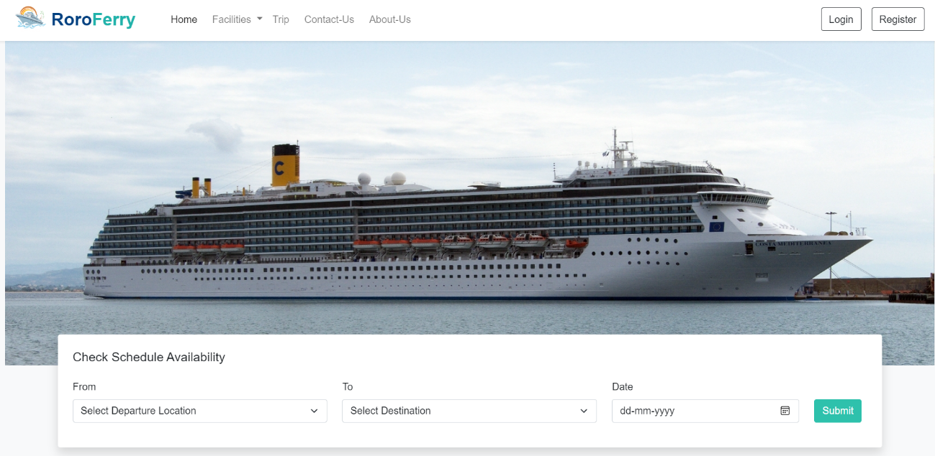

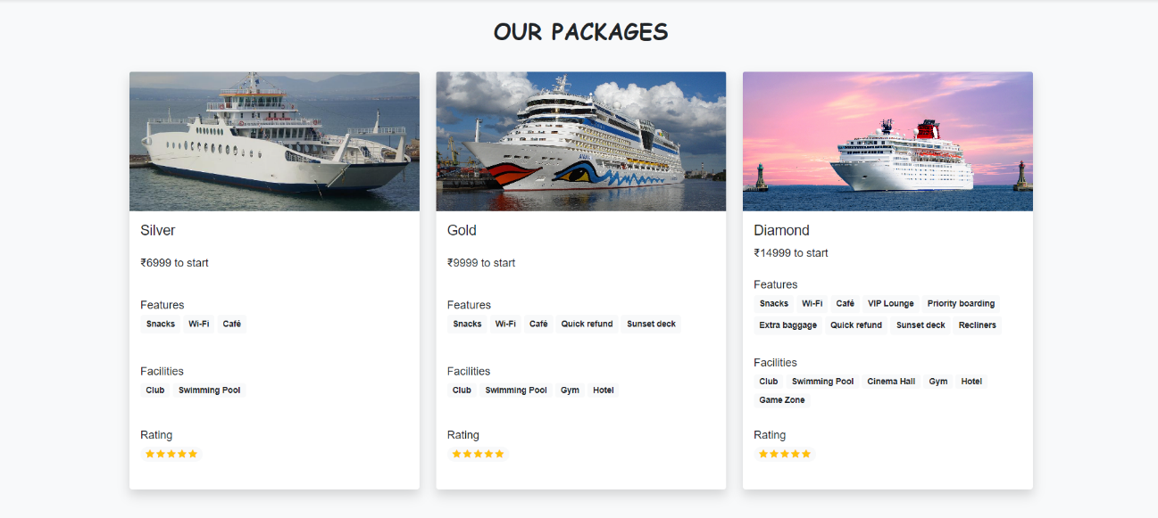

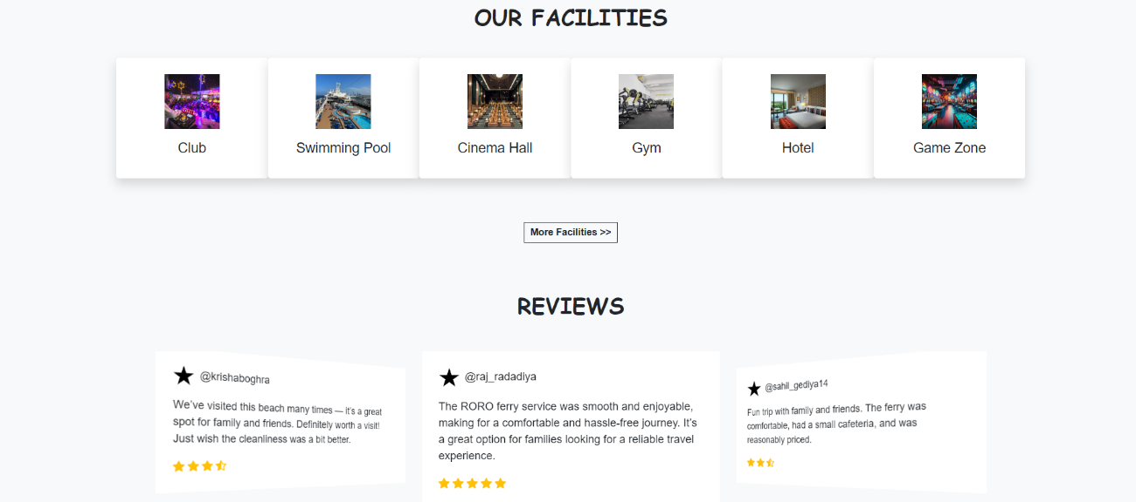

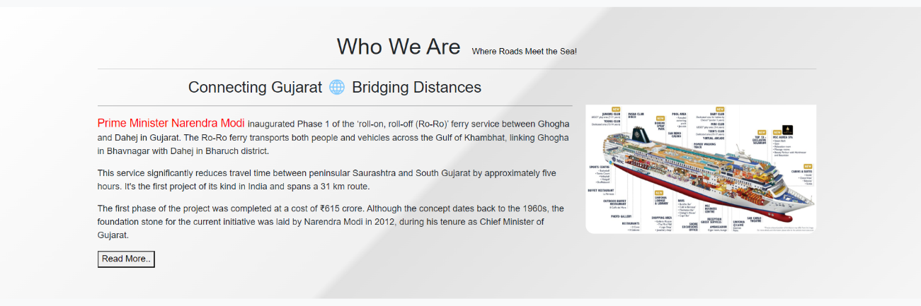

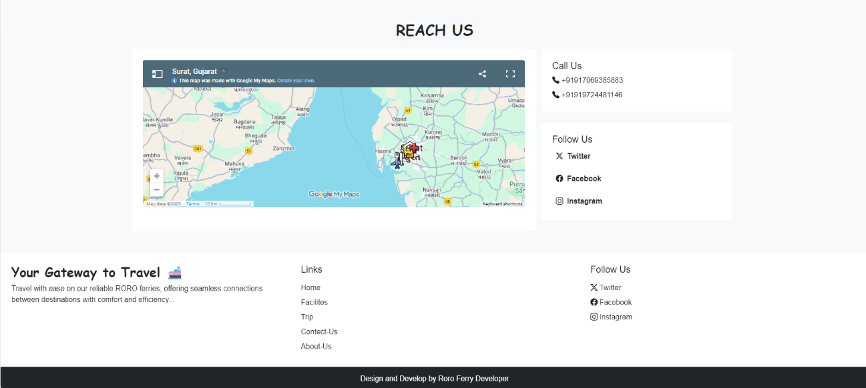

2. Register User

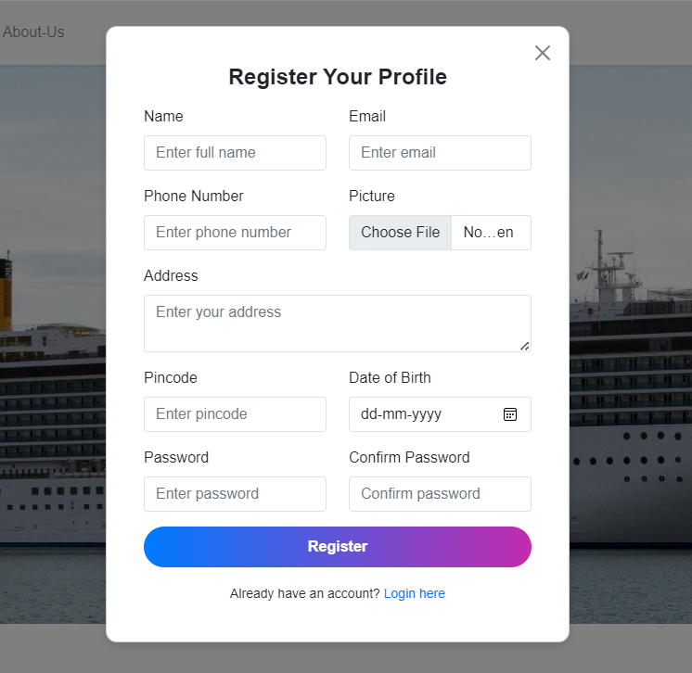

2.1 Alert Register

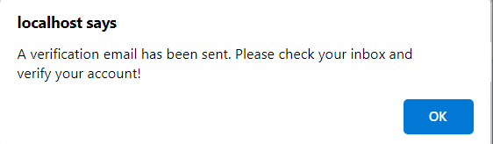

2.2 Email Verification
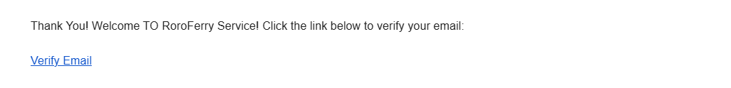
2.3 After Verification
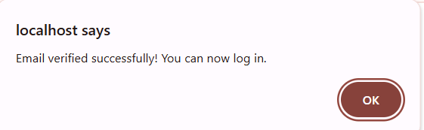

3. User Login

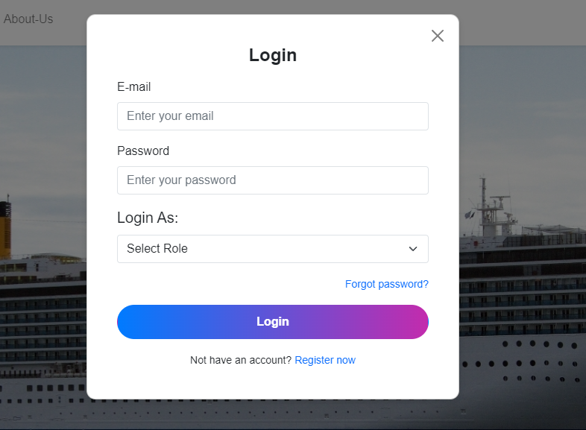

3.1 After Login

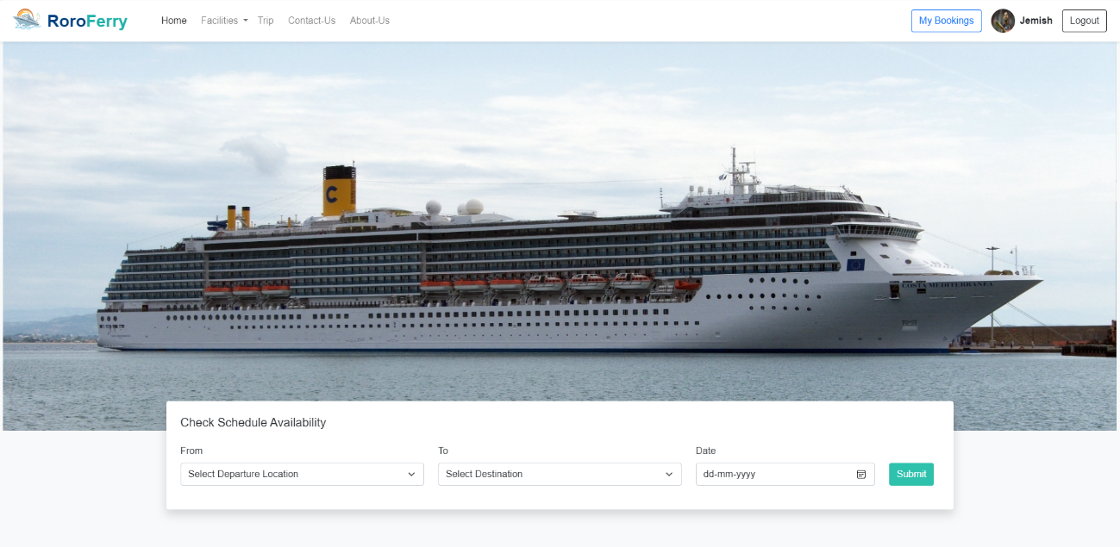

4. Forgot Password

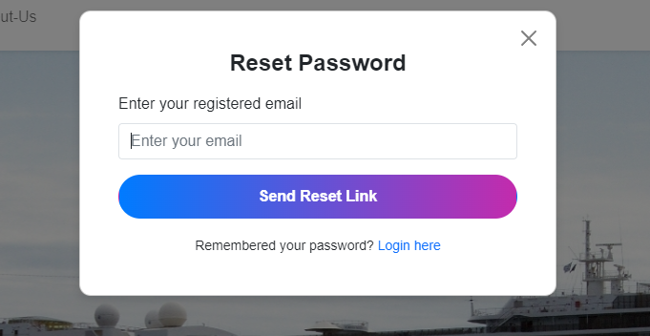

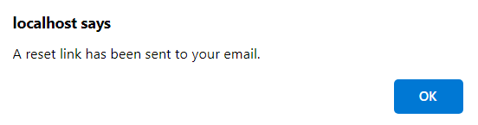

4.1 Reset Link
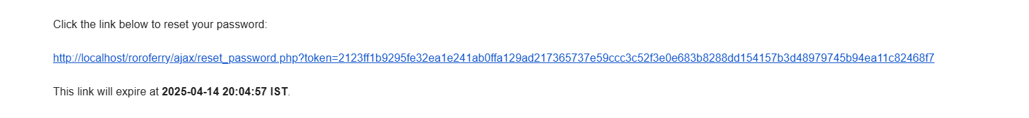

4.2 Reset Form

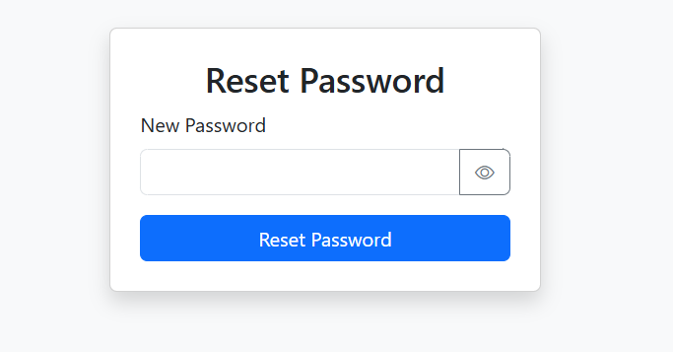

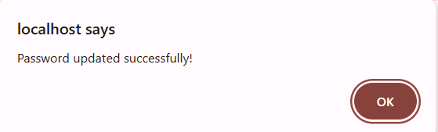

5. Facilities Page

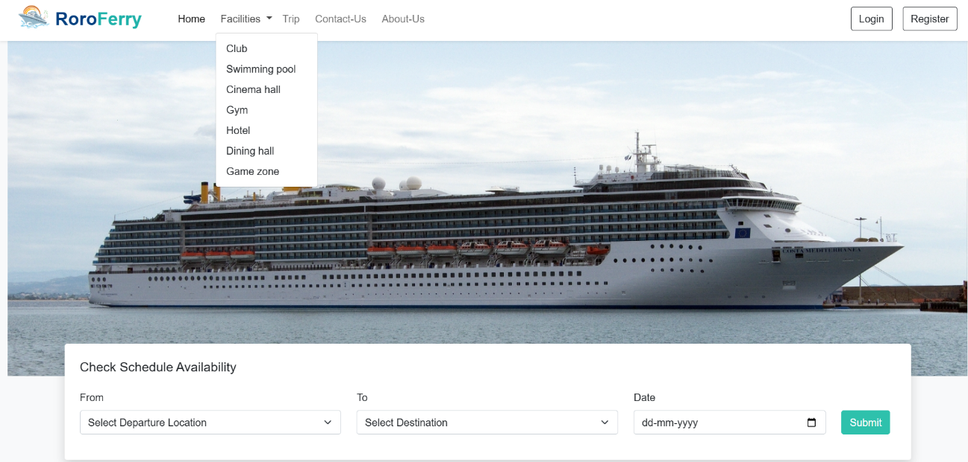

5.1 Club

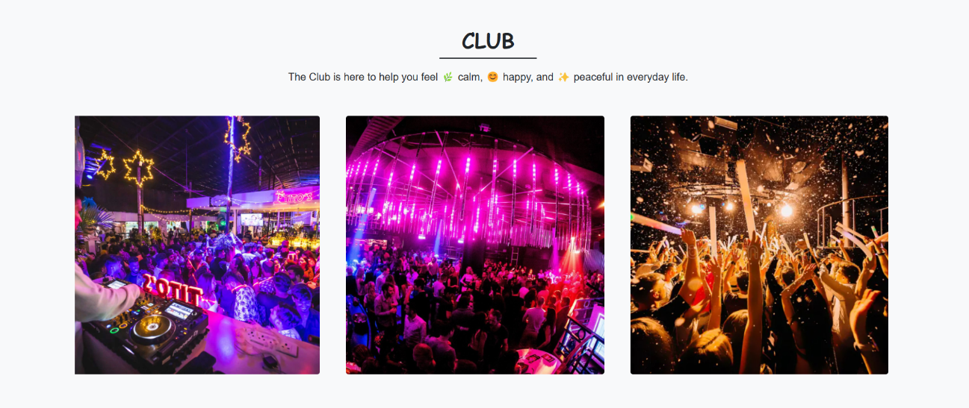

5.2 Swimming pool

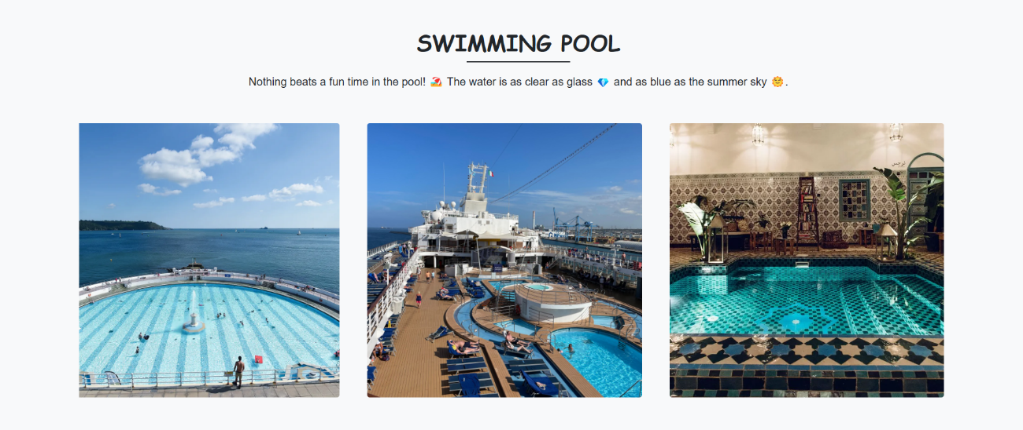
5.3 Cinema Hall

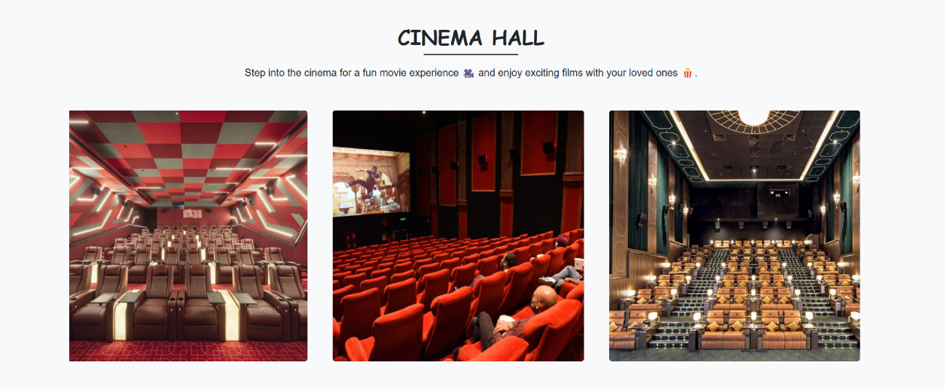

5.4 Gym

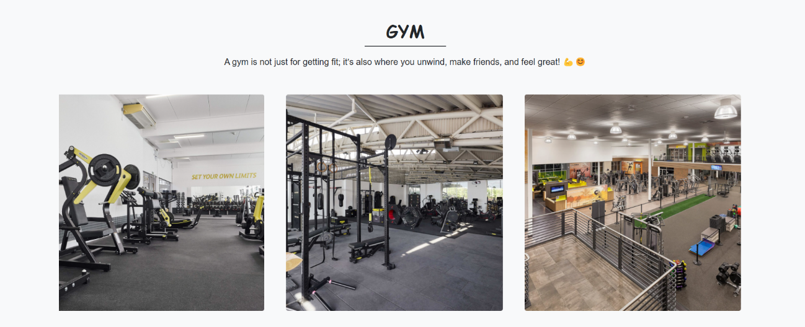

5.5 Hotel

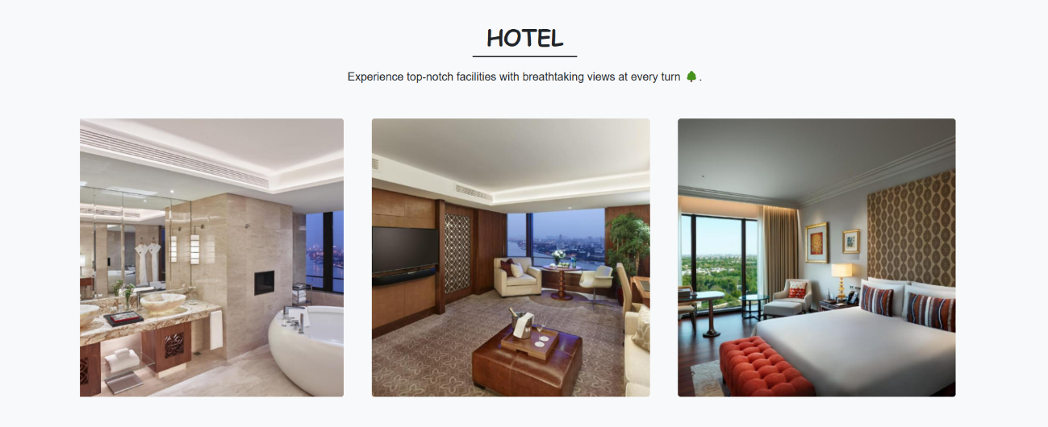

5.6 Dining Hall

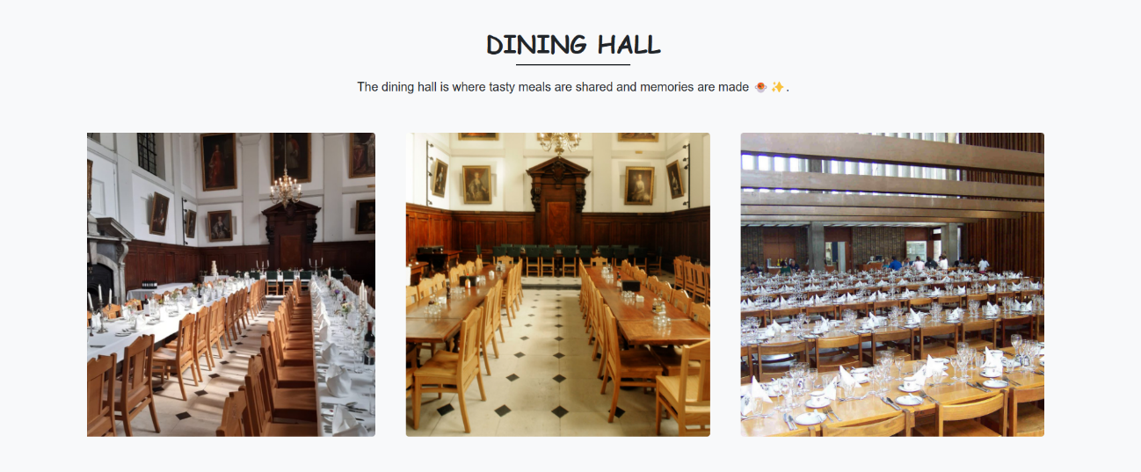

5.7 Game Zone

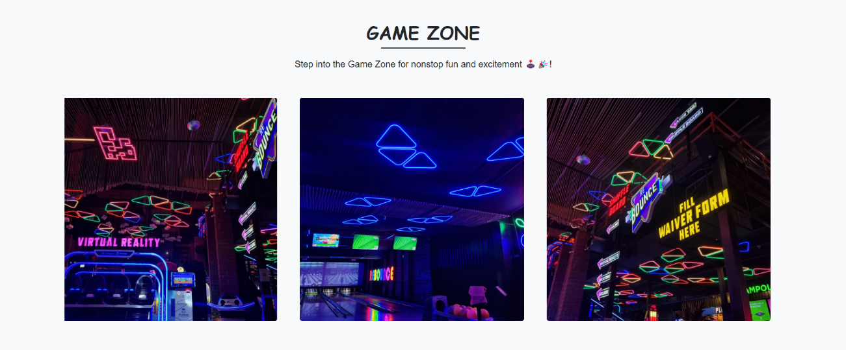

6. Trip Page

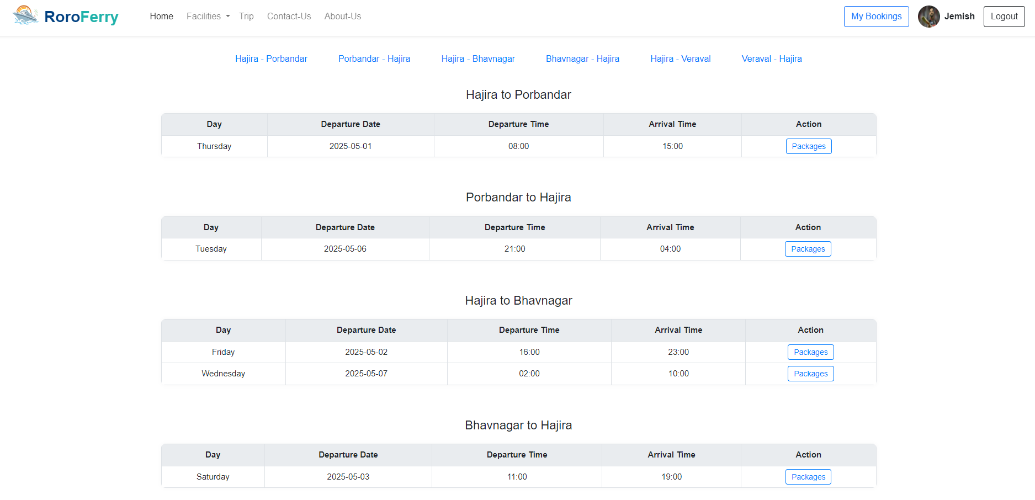
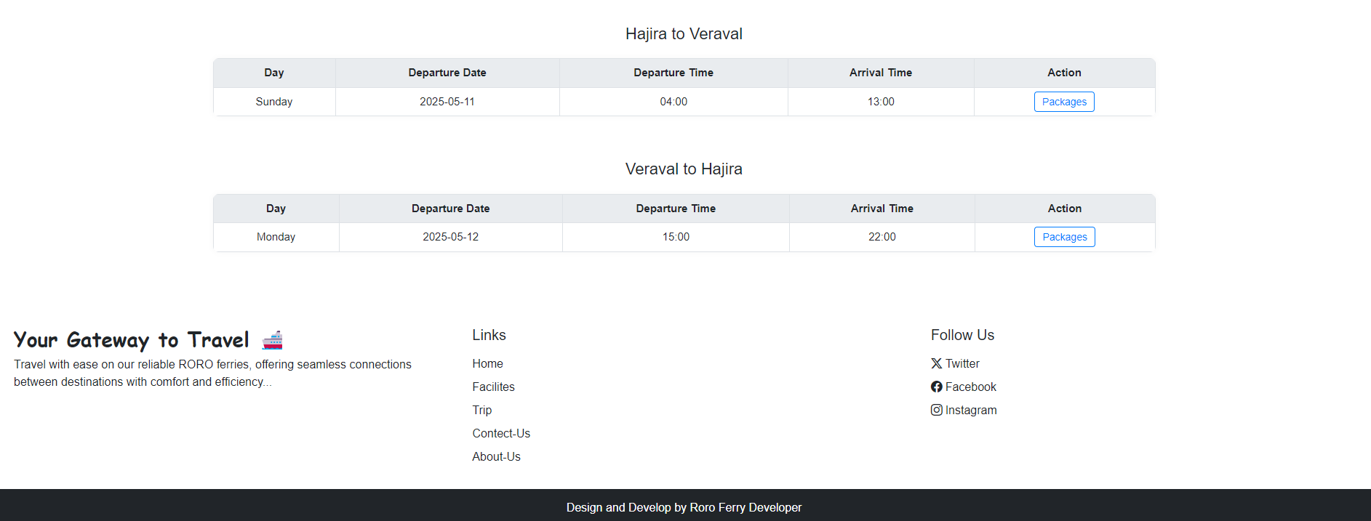

7. Contact-us page
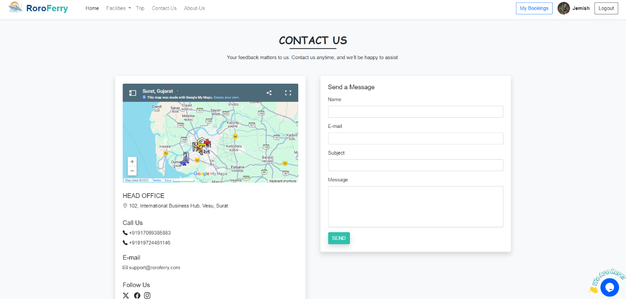

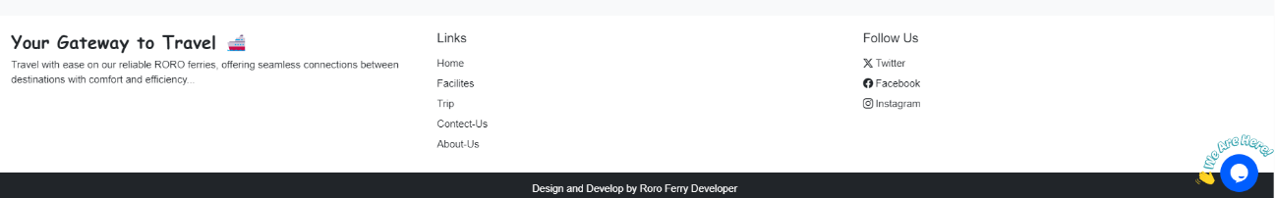

7.2 Chat Boat

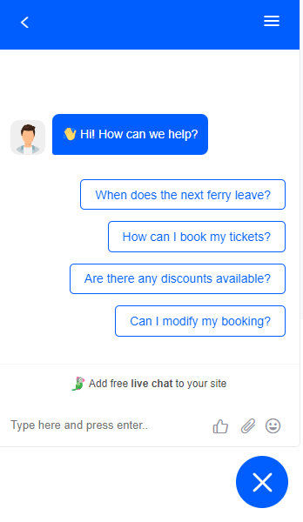
8. About Us Page

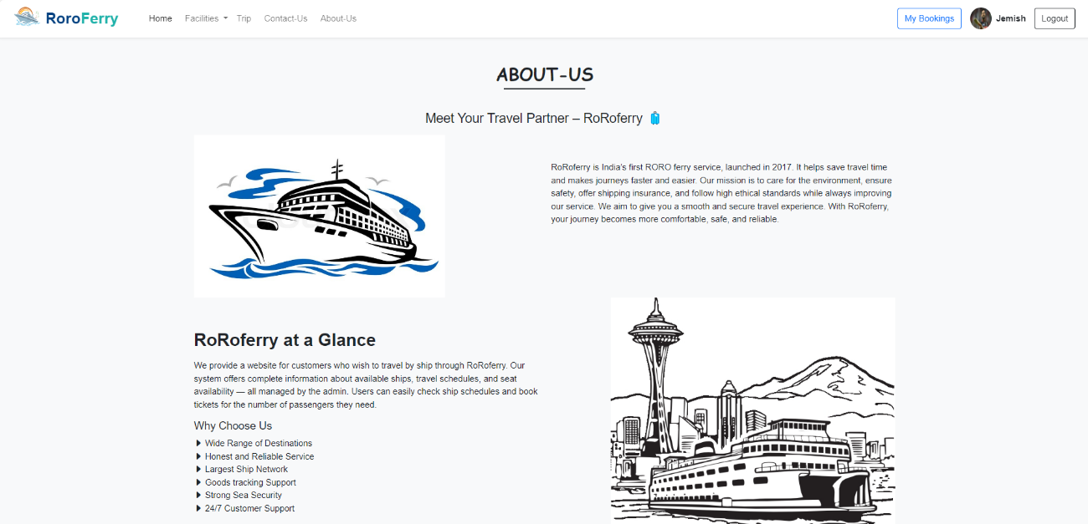
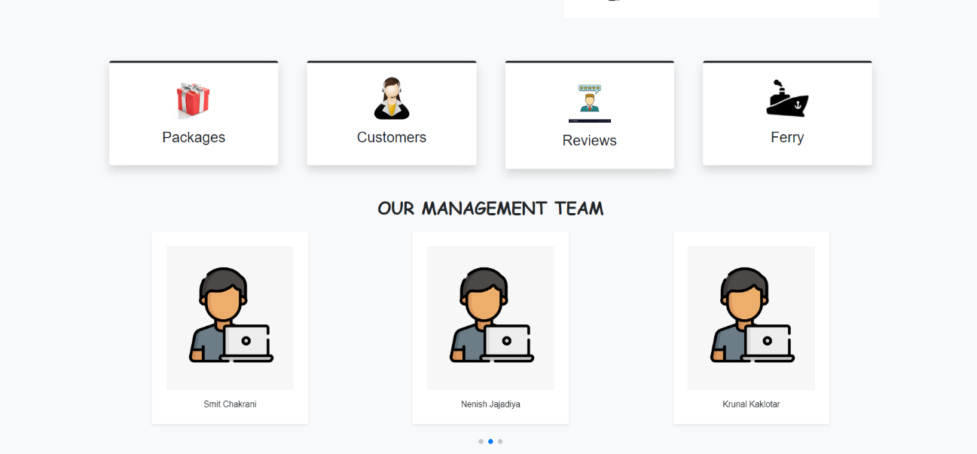
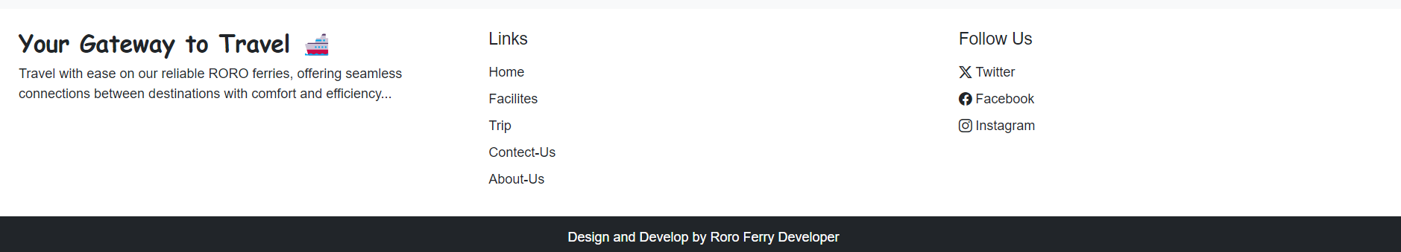

9. Booking process
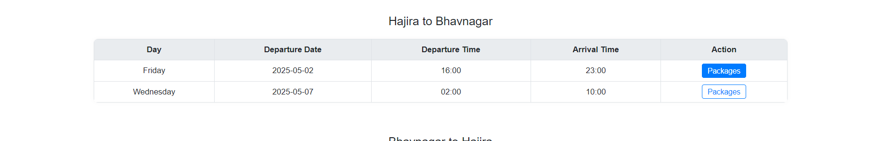

9.1 Packages Selection

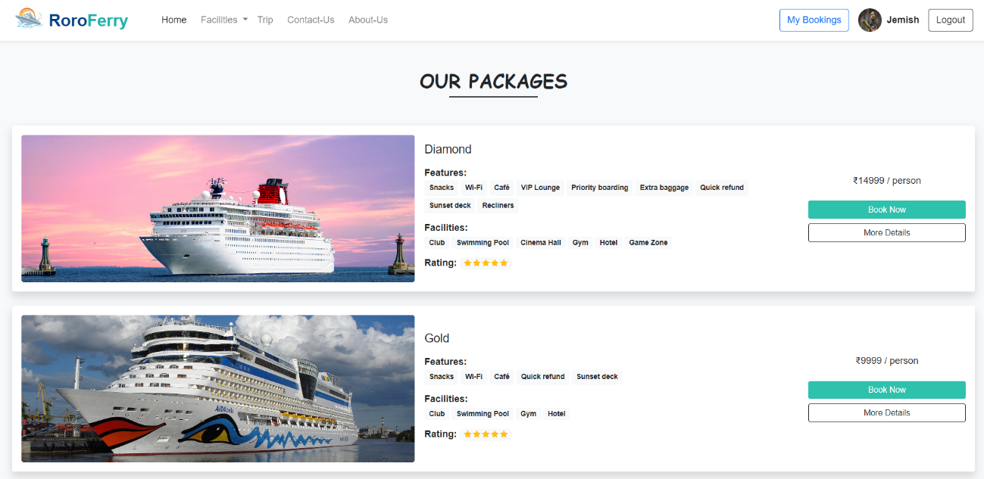
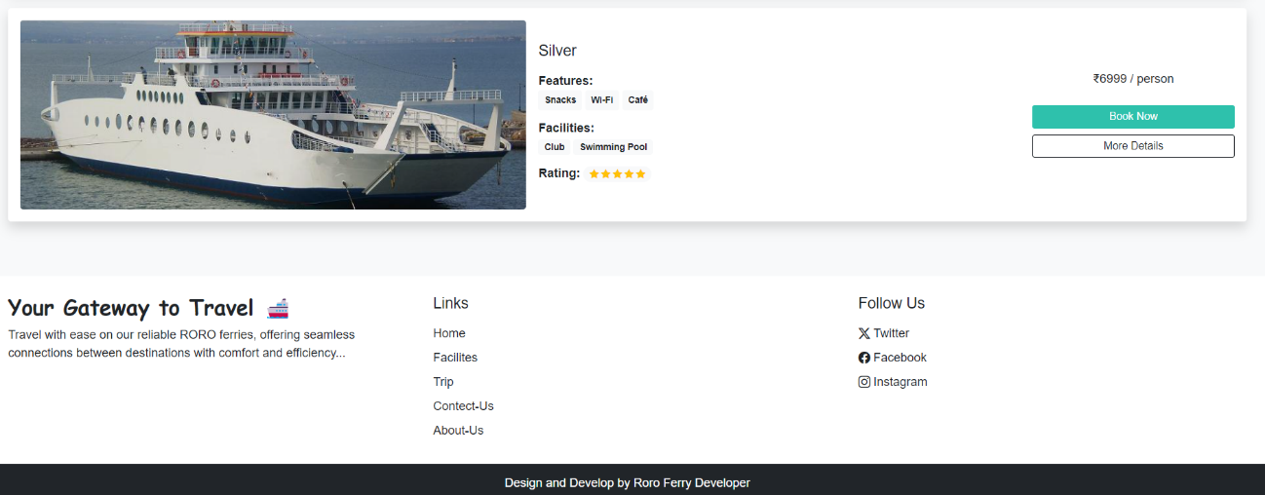

9.2 Package Details

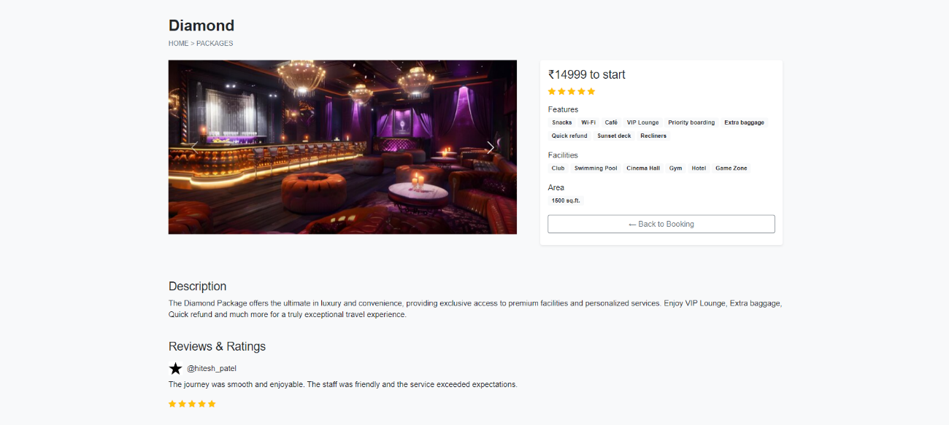

9.3 Seat Selection

9.3.1 Before selection

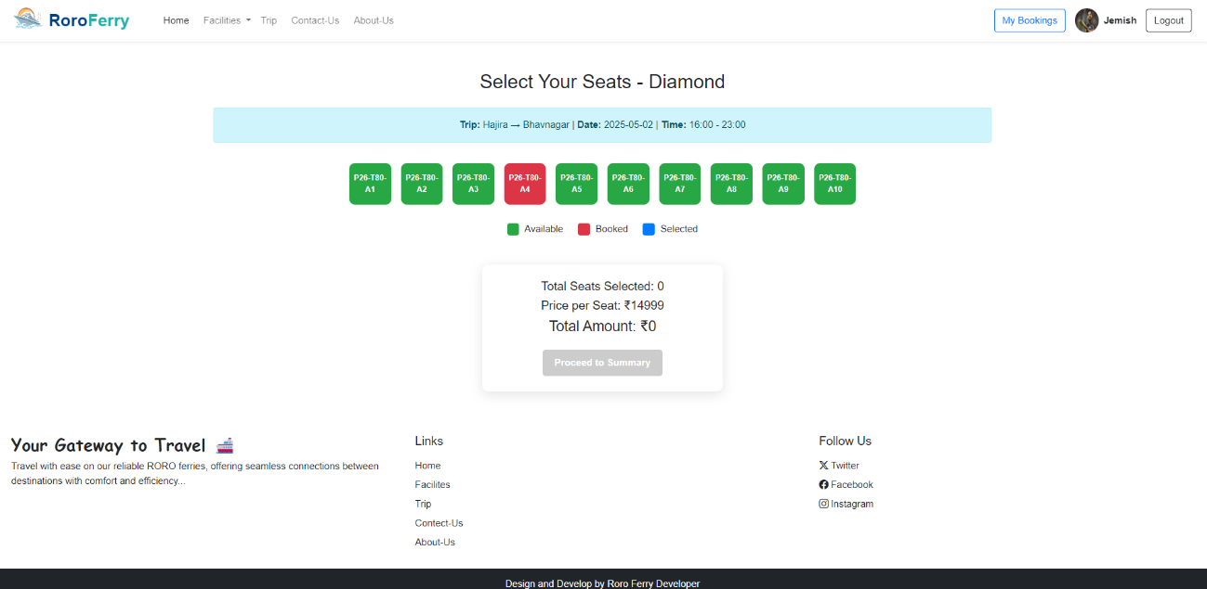

9.3.2 After selection

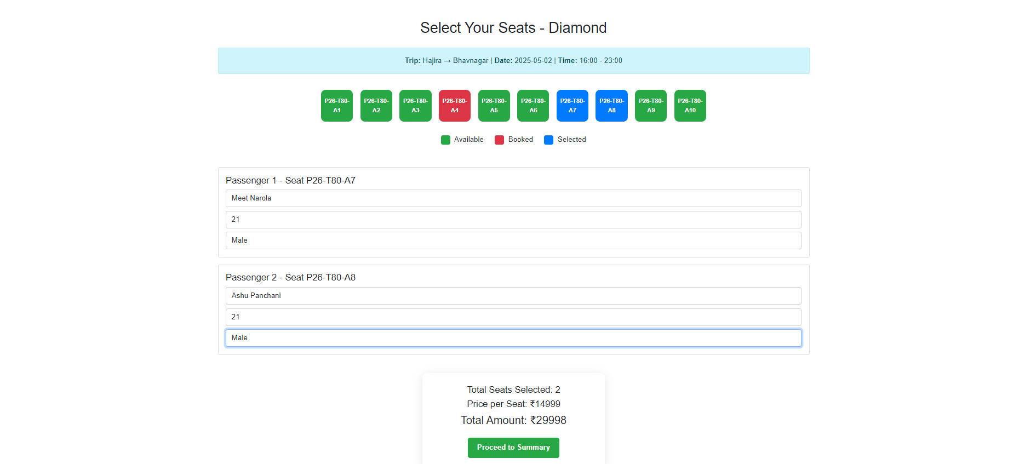

9.4 Summary Page
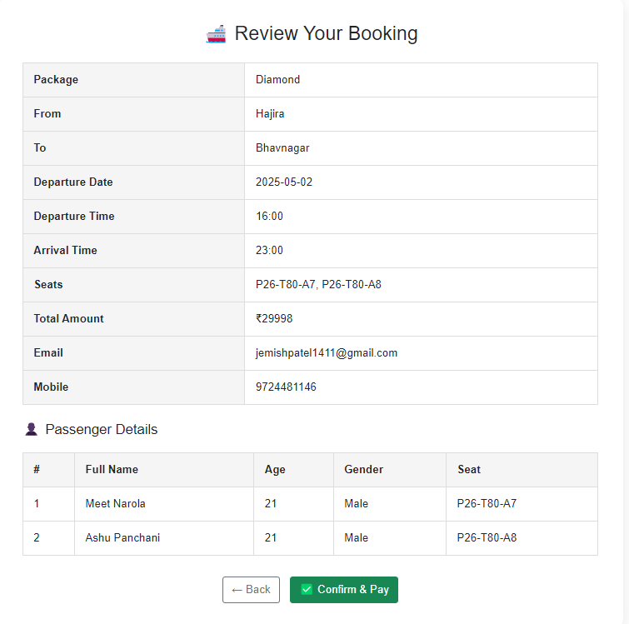

9.5 Payment Gateway

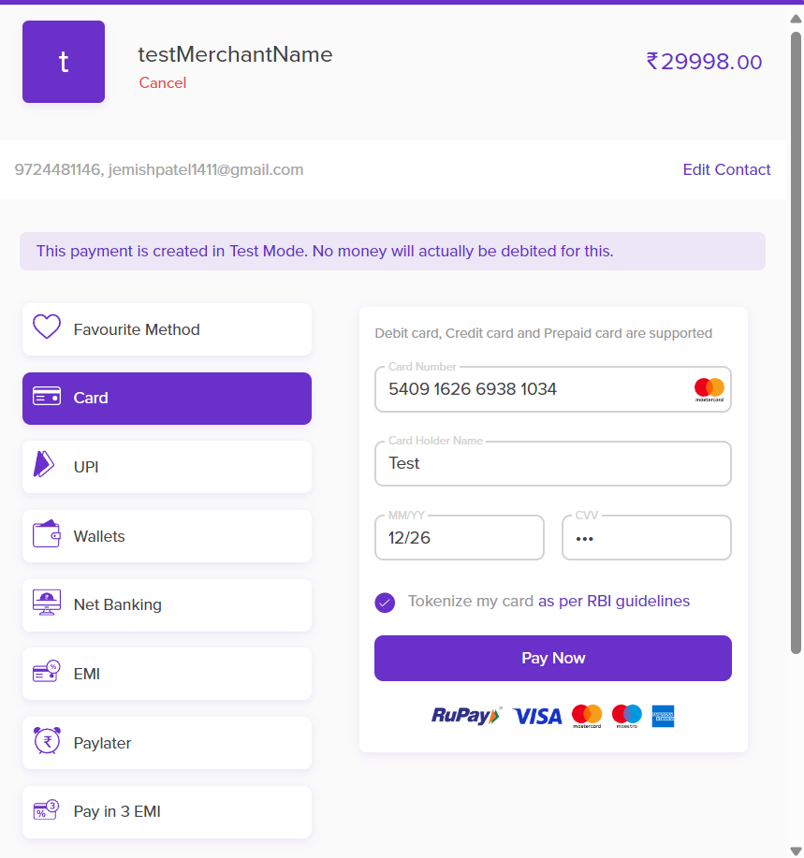

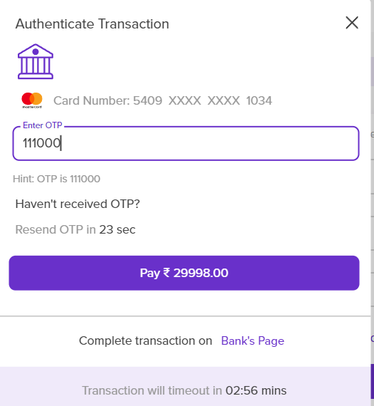
9.6 Payment Success

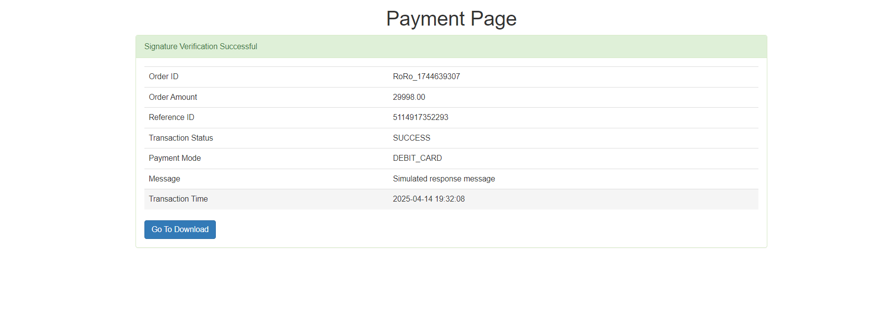

9.7 Booking Confirm

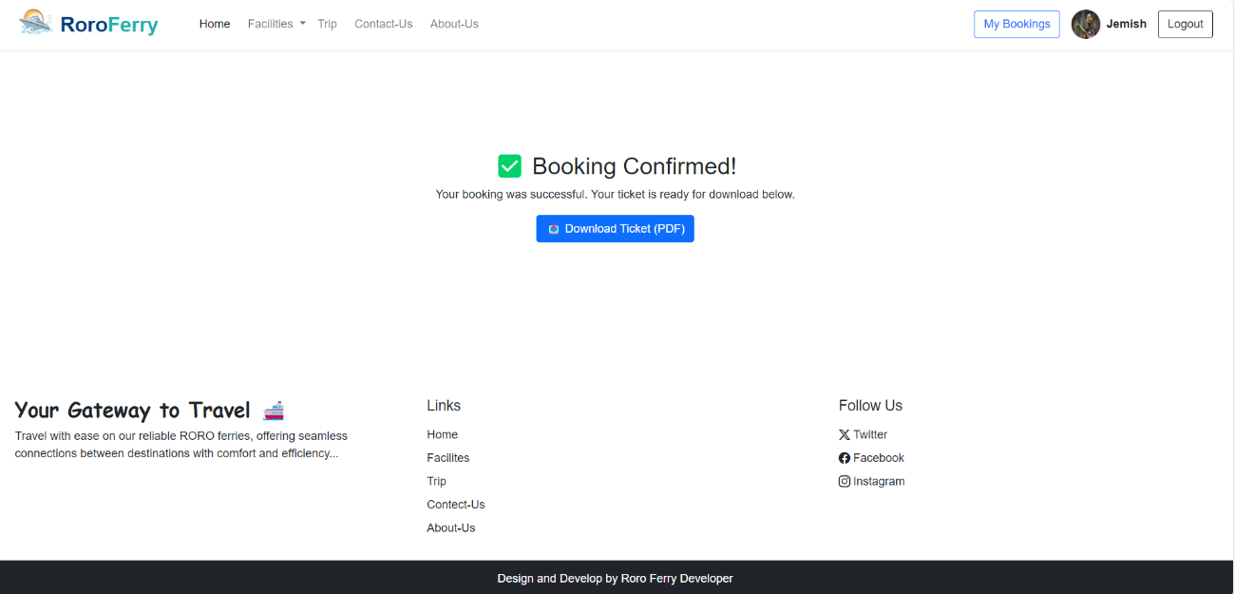

9.8 Ticket Generate

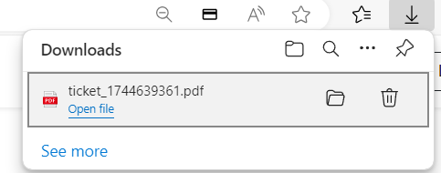

9.9 Ticket

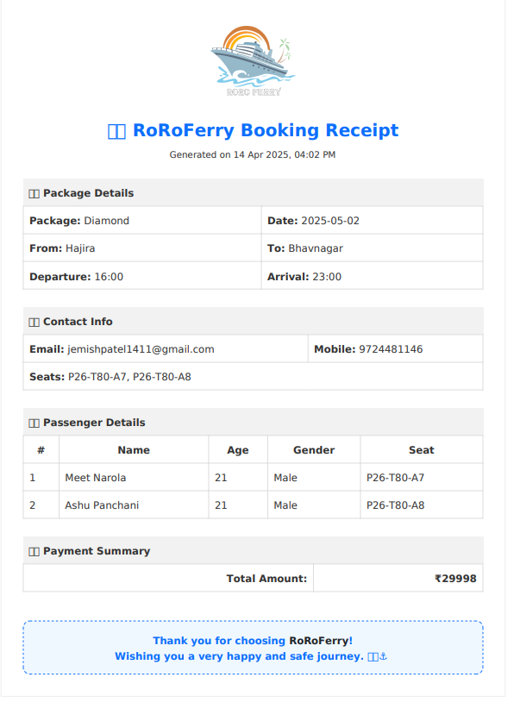

9.10 Email confirmation

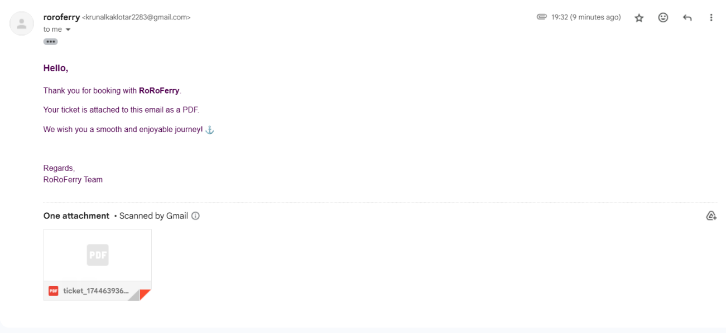

10. Booking History

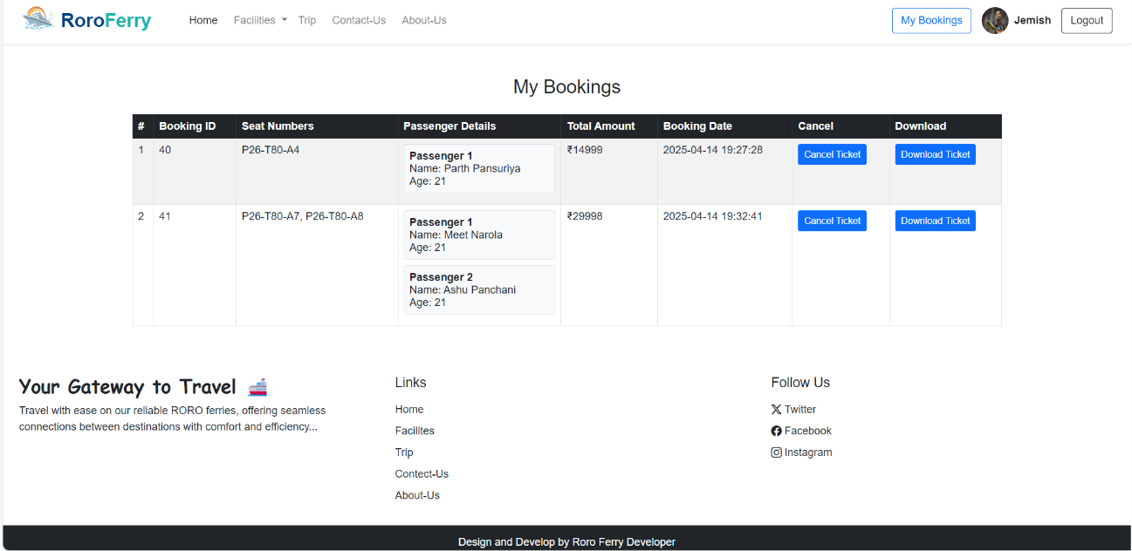

11. Cancel Booking

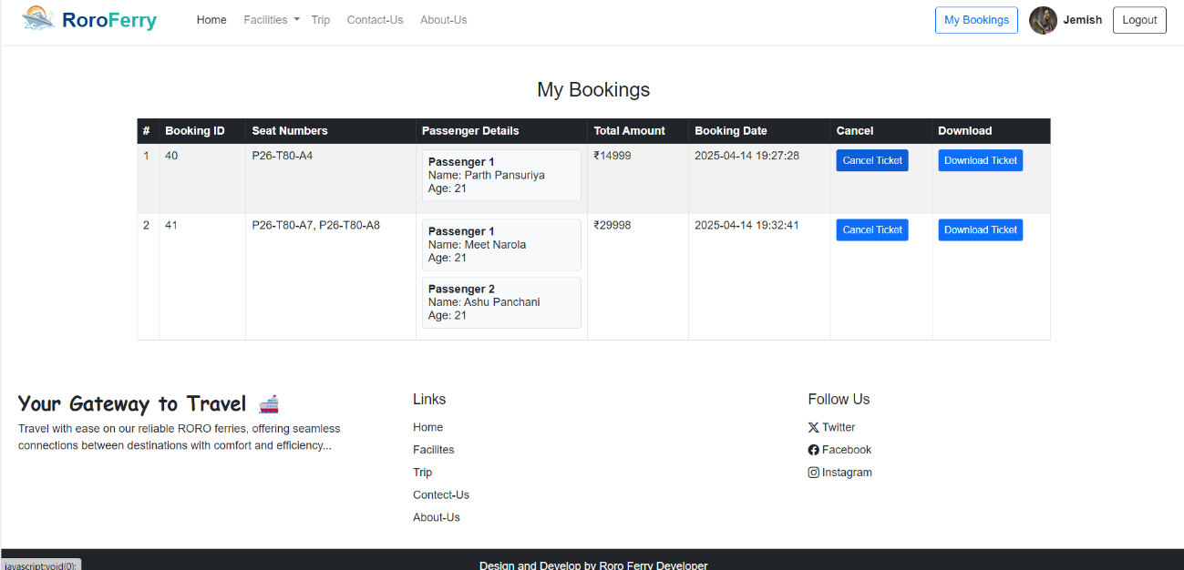
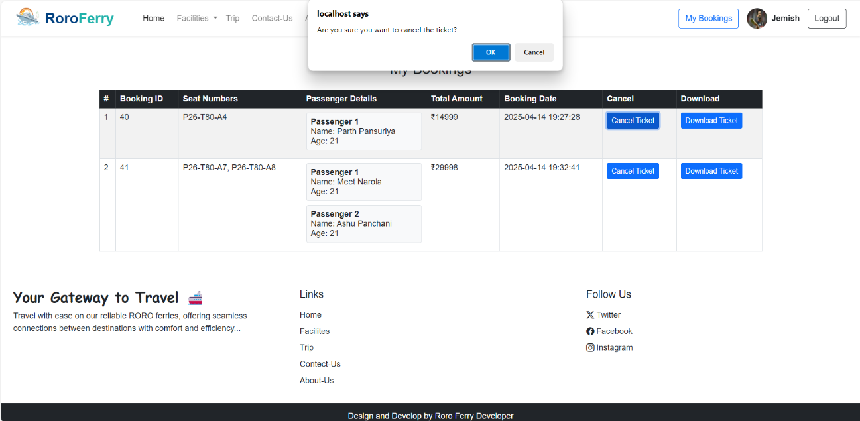

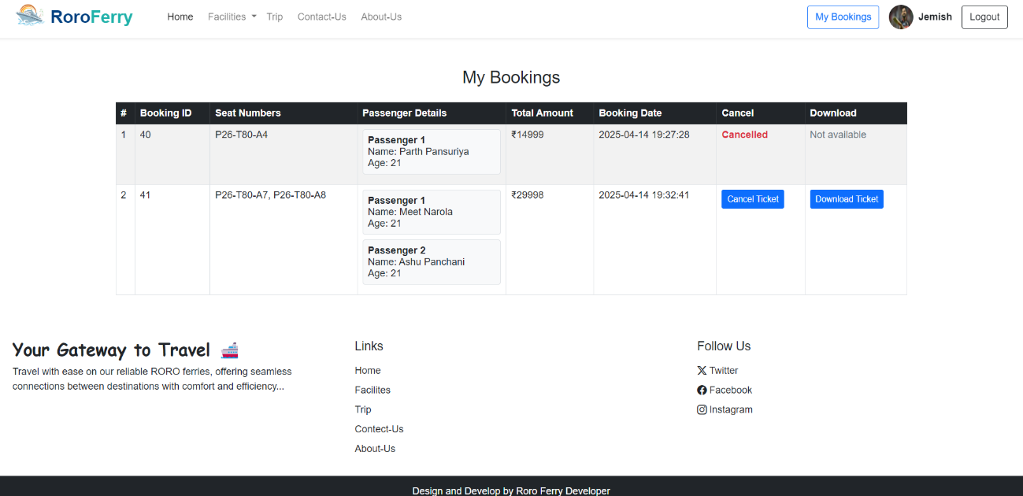

2. Admin Side

2.1 Admin Login

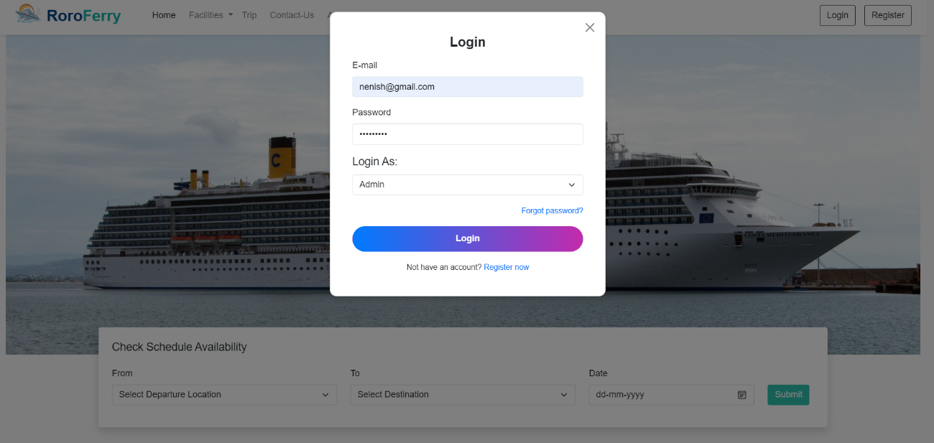

2.2 Admin Dashboard

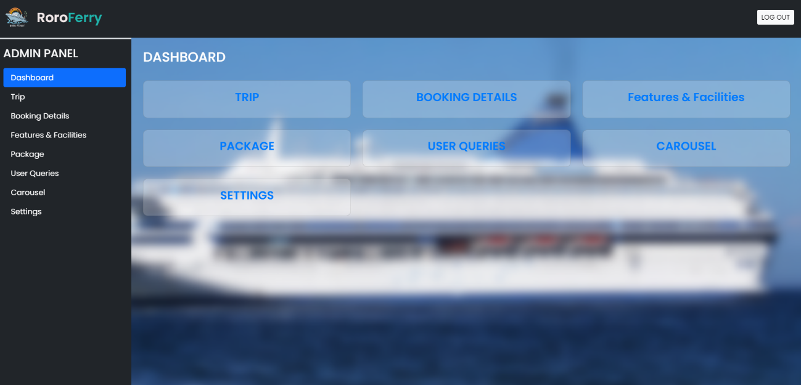

2.3 Trip

2.3.1 Trip Page

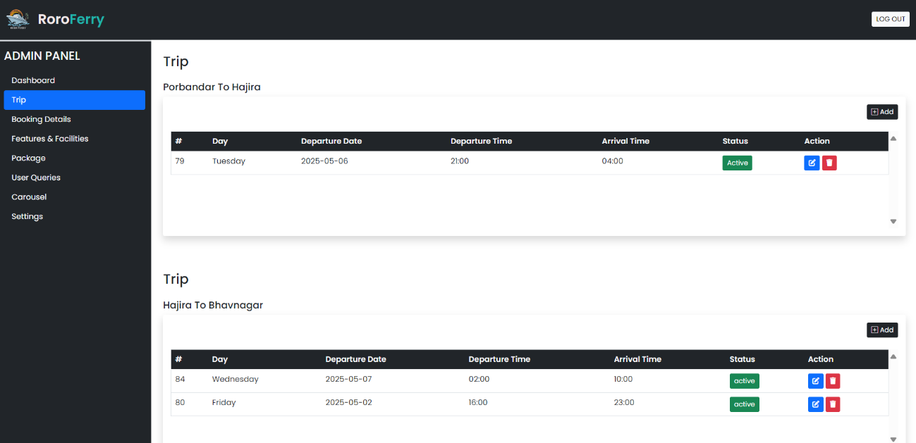

2.3.2 Add Trip

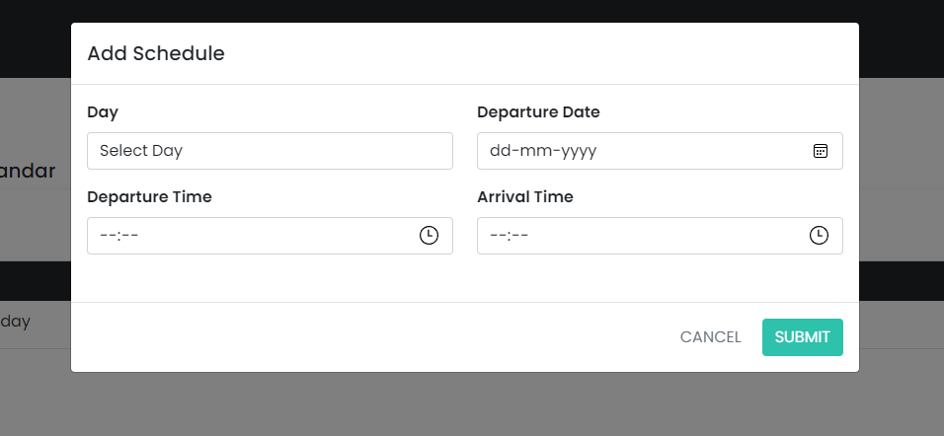

2.3.3 Edit Trip

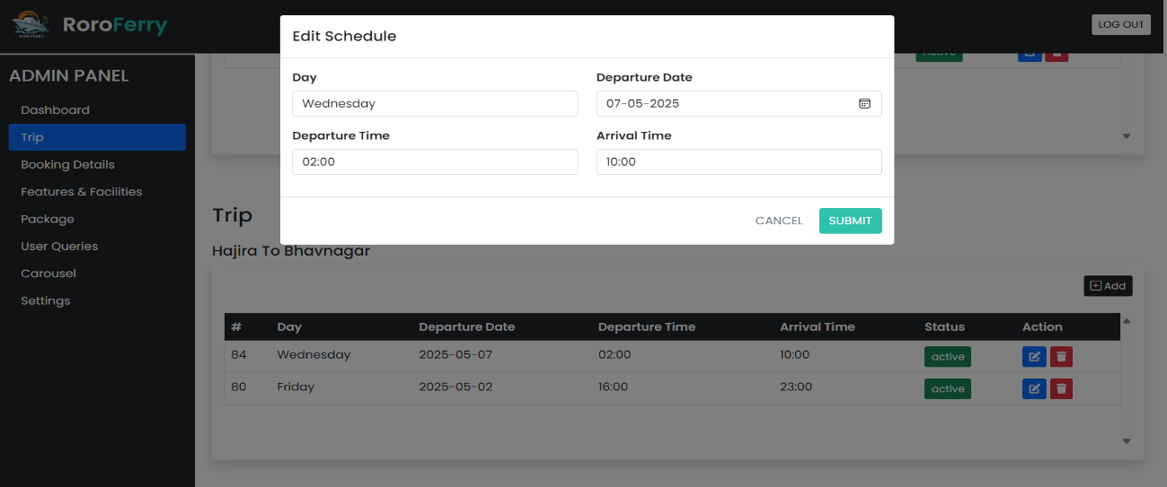

2.4 . Booking Details

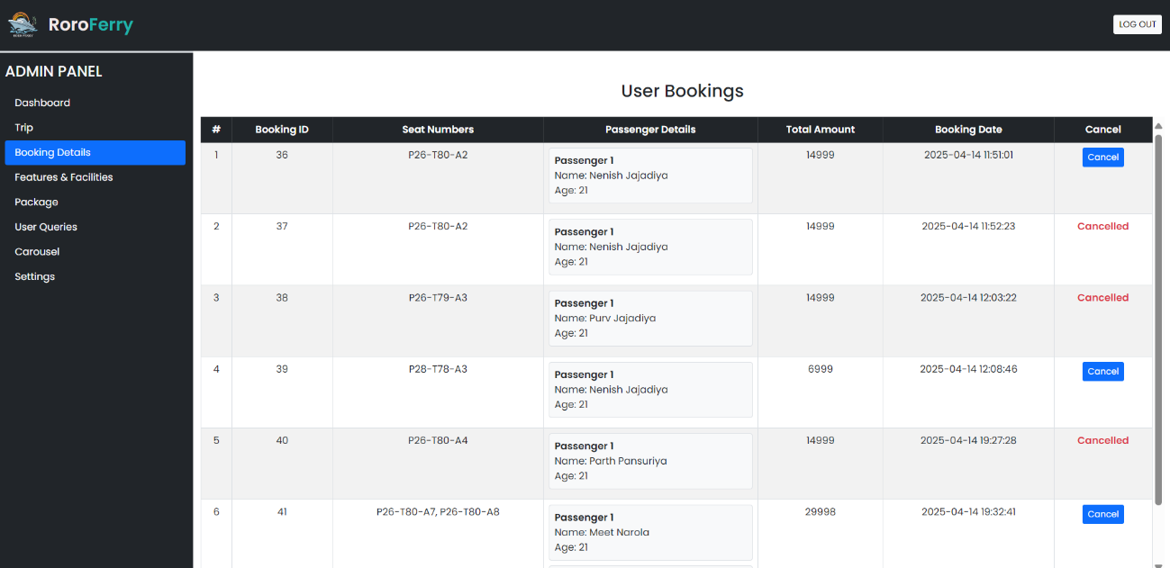

2.5 . Features & Facilities

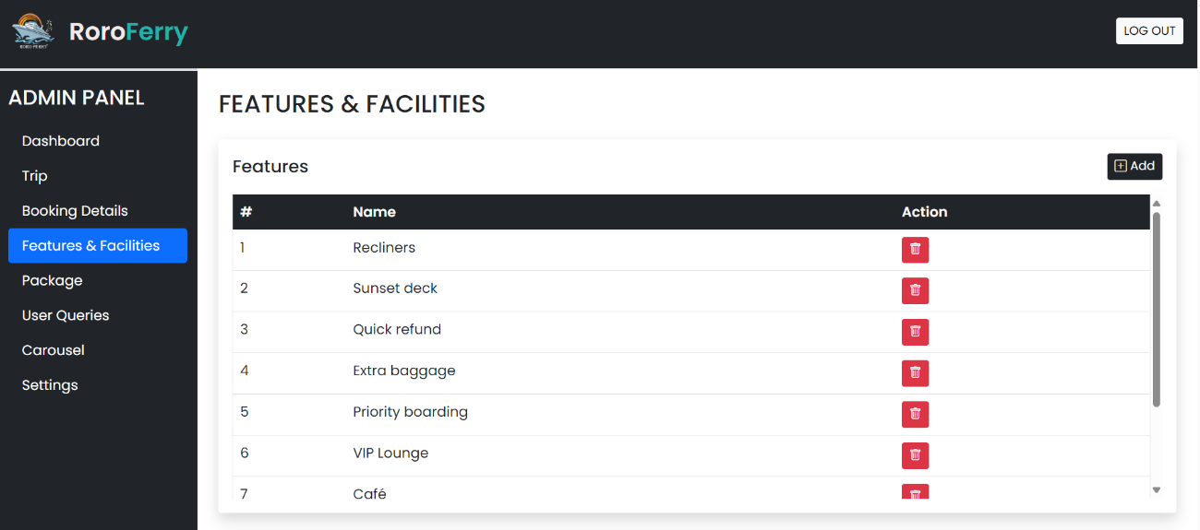
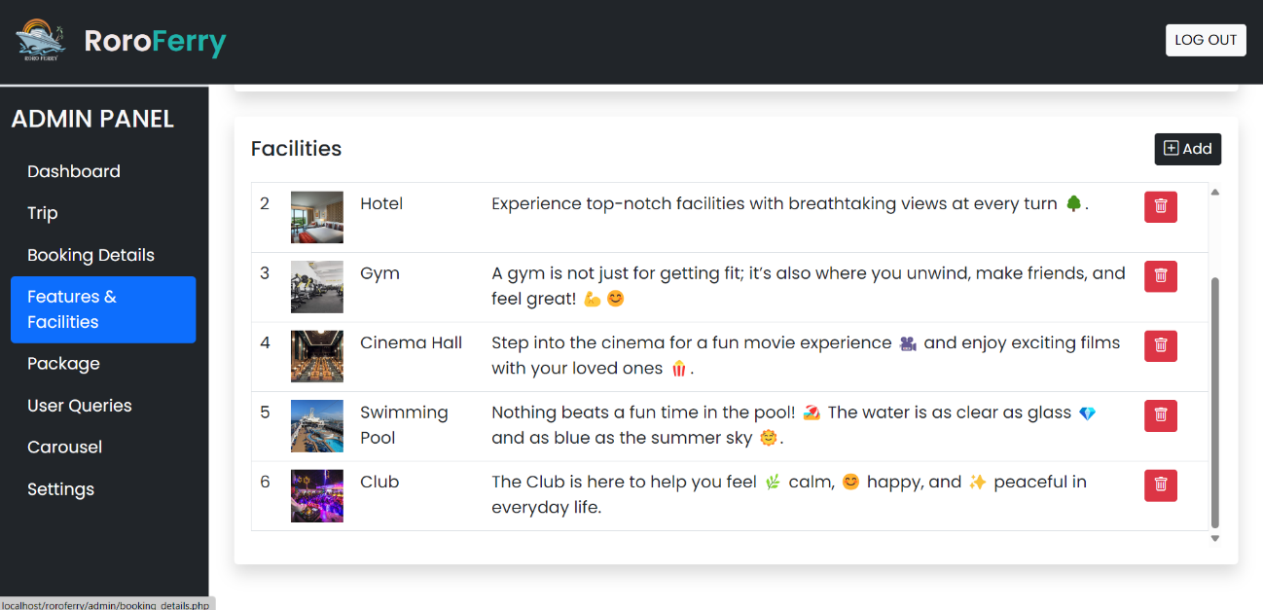

2.6 .Package

2.6.1 package page

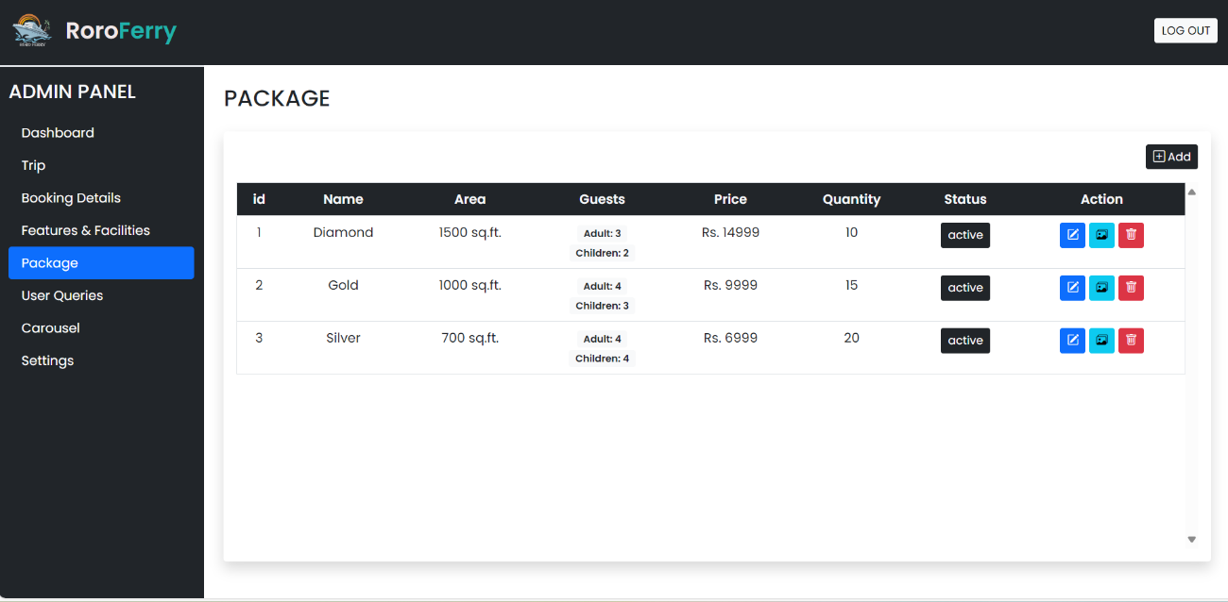

2.6.2 Add Package
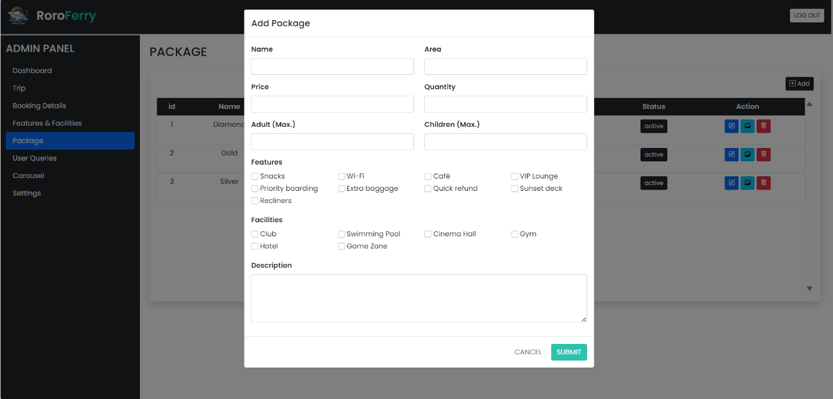

2.6.3 Add Image

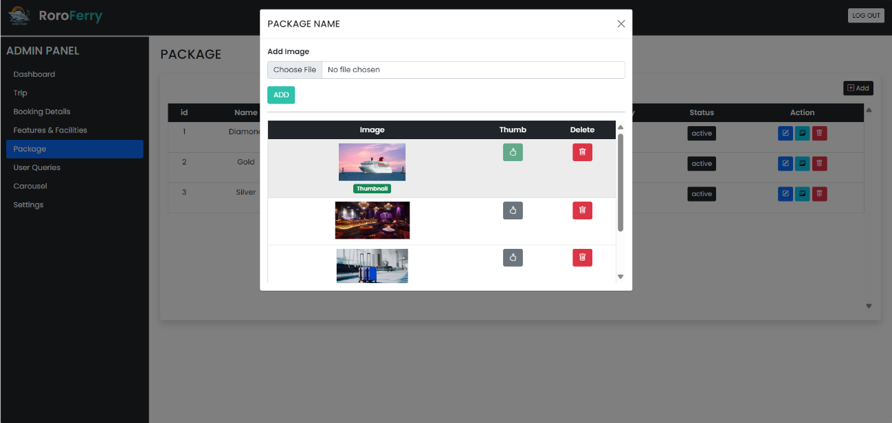

2.6.3 Edit Package

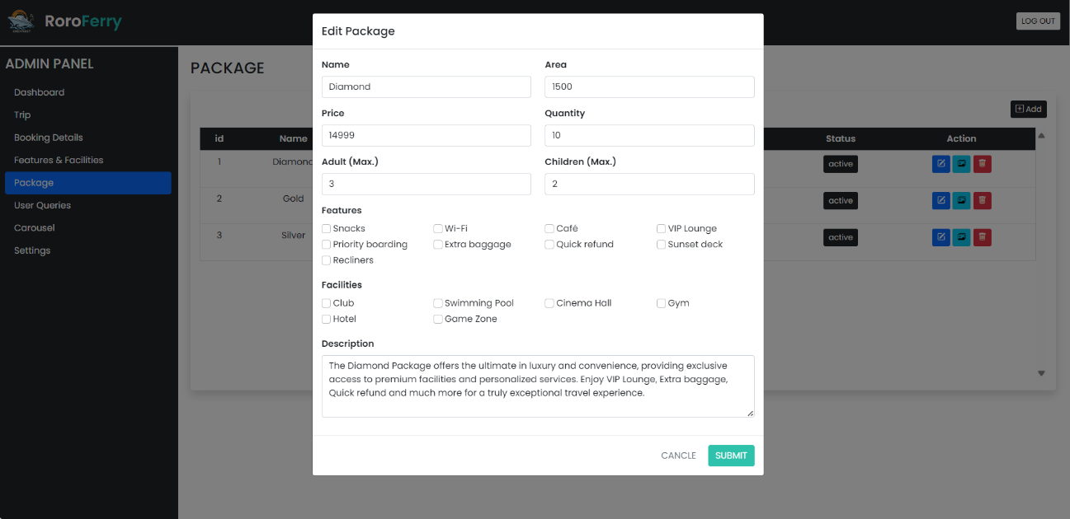

2.7 User Queries

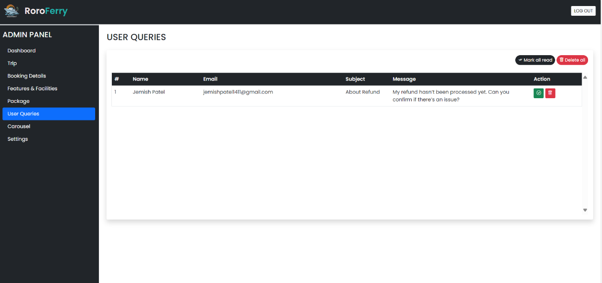

2.8 Carousel

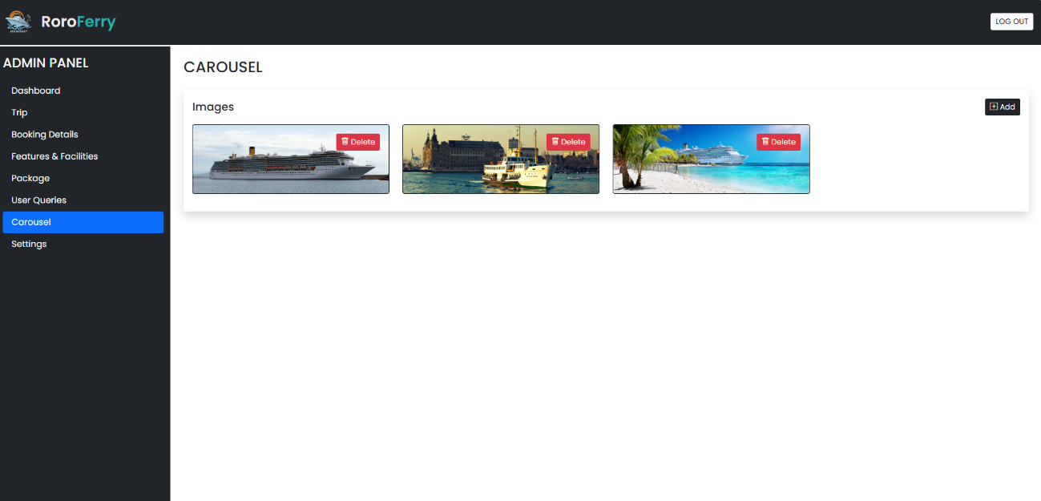

2.9 Settings

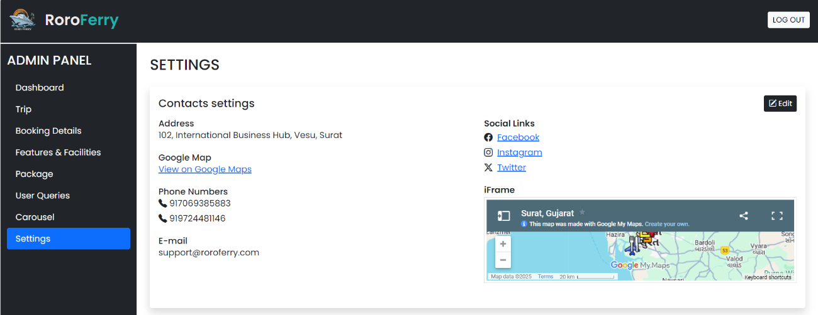

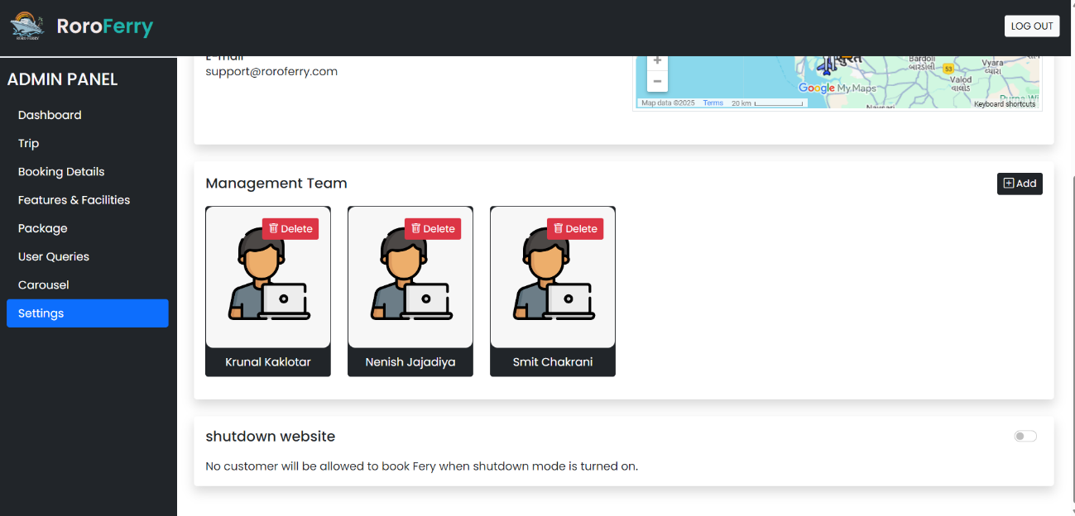

7. References

YouTube Links:

https://www.youtube.com/watch?v=iXFx88WQ44E

https://www.youtube.com/watch?v=-ojqccSIQs0

https://www.youtube.com/watch?v=iHHaCVjtPJM&t=22s

Reference Links:
https://en.wikipedia.org/wiki/RORO_ferries_in_India

Resource Links:
https://www.ics-shipping.org/explaining/

